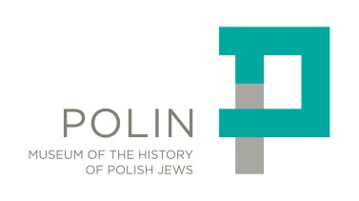
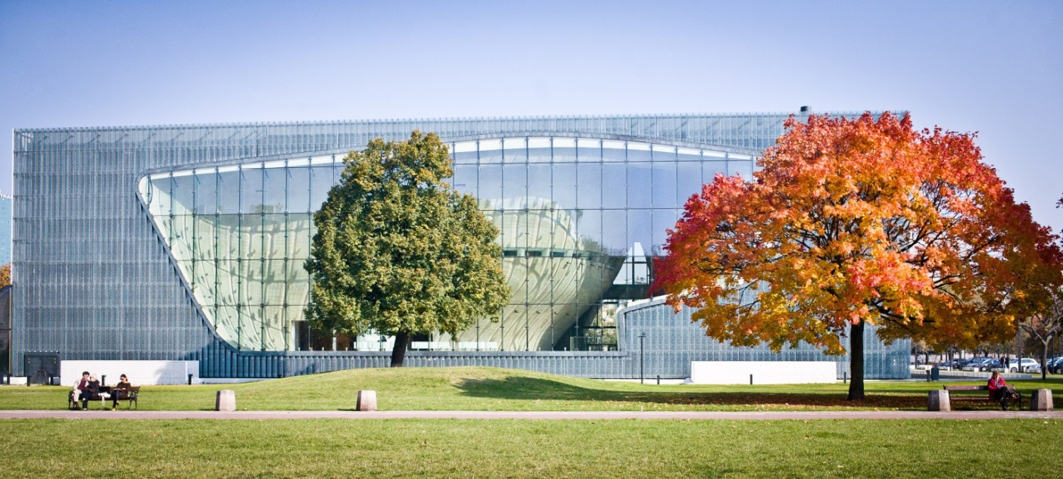
FACTS & FIGURES
POLIN Museum of the History of Polish Jews

Museum role and public mission
POLIN Museum of the History of Polish Jews (POLIN Museum) is the first and only museum dedicated to restoring the memory of the civilization created by Polish Jews in the course of a millennium. As a museum of life, it engages with the present and opens out to the future. As an educational and cultural institution, the museum is dedicated to stimulating dialogue in the spirit of mutual understanding and respect.
POLIN Museum was founded in symbolic place in the centre of Warsaw: Muranów - the area of the ​​pre-war district inhabited mainly by Jews and during the war transformed by the Germans into the ghetto. The museum completes the history of the place: the nearby Monument to the Ghetto Heroes commemorates the Polish Jews that died, and the museum is a reminder of how they lived.
While the chasm created by the Holocaust can never be repaired, the exhibition and the programs it inspires can build bridges across the rupture. Those bridges could reconnect Jews abroad to their own histories in Europe. They could reconnect people living in Poland today to the Jewish past of their own towns and cities – and to those who descend from the Jews who once lived there.
Formal status & cost of Museum development:
POLIN Museum is a public institution of Culture. It is the first public-private partnership institution of its kind in Poland created by the Ministry of Culture, City of Warsaw and the Association of the Jewish Historical institute of Poland. Under the founding act, the public party provided $60 million (PLN 180 million) for the construction of the Museum building, they also cover the major part of the Museum’s annual budget. The Association initiated the Museum project and was responsible for the development and production of the core exhibition. Thanks to the support of donors from all over the world, the Association raised $48 million (PLN 145 million) for this purpose.

Museum Director:
Professor Dariusz Stola is the director of POLIN Museum since March 2014. He is a historian, professor at the Institute of Political Studies at the Polish Academy of Sciences and at Collegium Civitas, a member of the team at the Centre for Research on Migration at the University of Warsaw. His research interests include the history of Polish-Jewish relations, the history of the People’s Republic of Poland and the history of international migration in the 20th century. He has published more than 100 academic articles, 10 books and three history textbooks for secondary schools. He is a long-time academic lecturer, participant in research projects and a member of the scientific editorial boards of a number Polish and international institutions and academic journals.
Previous Museum directors include (in chronological order):
Jerzy Halbersztadt
Agnieszka Rudzińska (acting Director)
Andrzej Cudak (acting Director)

Museum core exhibition 1000 Year History of Polish Jews:
The core exhibition is a journey through the 1000-year history of Polish Jews – from the Middle Ages until today. Visitors can discover how Jews first arrived in Polish lands, why they stayed, and how Poland became home to one of the largest Jewish communities in the world – there were 3.3 million Jews in Poland before the Holocaust. While the number of Jews in Poland today is small, there has been a renewal of Jewish life since the fall of communism.
The core exhibition is divided into seven historical periods beginning in the tenth century, coming forward to the present, and opening out to the future. Historical galleries are introduced by an artistic installation: a poetic forest.
The galleries names and tie periods covered are:
Forest (a legend about the origins of the Jewish presence in Poland),
First Encounters (960–1500),
Paradisus Iudaeorum (1569–1648),
The Jewish Town (1648–1772),
Encounters with Modernity (1772–1914),
On the Jewish Street (1918–1939),
Holocaust (1939–1945),
Postwar Years (1944-to the present).

For detailed information on Museum core exhibition please refer to the specific press material and the short guide available on www.polin.pl website (section: MEDIA)

Museum building & architecture:
The Museum building is designed by the Finnish studio Architects Lahdelma & Mahlamäki, who won the international architectural competition for the design of the Museum building in 2005. Chief architect of the building is Professor Rainer Mahlamäki. Construction works took from June 2009 till March 2013.
For detailed information on Museum building & architecture please refer to the specific press material available on www.polin.pl website (section: MEDIA)

Museum history:
1993, April: First proposal that the Association of the Jewish Historical Institute should open a Museum of Life to present the history of Jews in Poland.
1997, April: The City of Warsaw grants the 13,000 sq. m. land plot designated for the Museum in front of the Monument to the Ghetto Heroes.
1999: Event Communications, a UK company, is selected to design the core exhibition of the Museum; it begins work the following year.
2002: Barbara Kirshenblatt--Gimblett, professor of performance studies at the Tisch School of the Arts, New York University becomes a core consultant and later the Program Director of the exhibition.
2005, January: Warsaw Mayor Lech Kaczyński, Culture Minister Waldemar Dąbrowski and Prof. Jerzy Tomaszewski, deputy chair of the Association of the JHI in Poland, sign an agreement establishing a joint cultural institution, the Museum of the History of Polish Jews.
2005, January-June: International architectural competition for the design of the Museum building.
2009, June: Construction of the Museum officially begins.
2011, September: Nizio Design International, a Polish company, is selected to complete the design and implement the core exhibition on the basis of the concept developed by Event Communications.
2013, April 19.: Gala opening of the Museum’s building, with the participation of Polish government officials and guests from around the world. Cultural and educational projects are lunched: theatrical and musical stages, film series, educational activities for children and families, academic lectures.
2014, October 28.: Grand Opening of the core exhibition of POLIN Museum.
For detailed information on Museum project history milestones please refer to the specific press material available on www.polin.pl website (section: MEDIA)

Why POLIN Museum?
According to the legend, Jews fleeing persecution in the Middle Ages came east. When they arrived in a forest, they heard the word Polin, which sounded like “Rest here” in Hebrew. They knew then that this was the place to settle. Polin is the Hebrew word for Poland and the inspiration for the name of the Museum of the History of Polish Jews.
Gershom Bader in his book from 1927 Draysig Doyres Yidn in Poyln (Thirty Generations of Jews in Poland) quotes the legend from oral tradition:
(…) legend has it that after they decreed a fast and beseeched God that he should save them from the hands of their murderers, there fell from the heavens a slip of paper on which was written: ‘Go to Poland and there you will find rest’.
The Jews set out for Poland. When they arrived, birds in the forest greeted them. They chirped "Po lin! Po lin!" The travelers interpreted these sounds according to the Hebrew language, as if the birds wanted to tell them, ‘Here you should pass the night ...’ And when they caught sight of the trees, it seemed to them that a page of the Gemara was hanging from every little branch. They understood at once that here a new place had been revealed to them where they could settle and continue to develop the Jewish spirit and age-old Jewish learning (…)".

Media contact
Grzegorz Tomczewski
Media Relations
gtomczewski@polin.pl
+48 535 050 204
Iwona Oleszczuk
ioleszczuk@polin.pl
+48 604 451 422

