Who do Poles see when they see a Jew?
Report on research carried out by the POLIN Museum of the History of Polish Jews
Edited by Marcin Napiórkowski
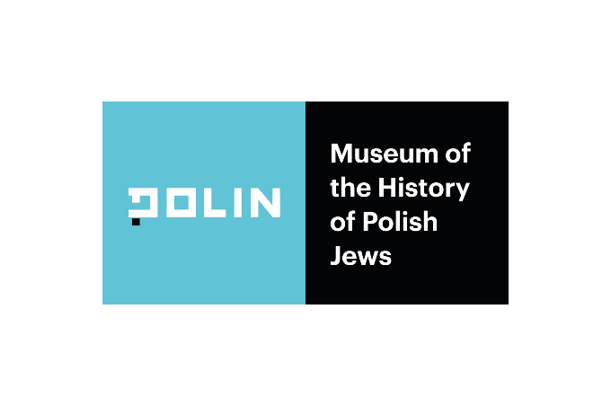

Research authors:
Semiotic Solutions (Joanna Damaszko, Marcin Napiórkowski, Krzysztof Polak, Marzena Żurawicka), WiseRabbit (Marta Bierca, Dorota Wiszejko-Wierzbicka)
Content editor of the report:
Marcin Napiórkowski
Consultations:
Katarzyna Krauze, Dagmara Mańka-Wizor, Jakub Woźniak, Małgorzata Zając
Project coordination:
Dagmara Mańka-Wizor, Małgorzata Zając
Translation:
Ewa Kanigowska-Gedroyc
Proofreading:
Simon Wloch
Graphic design, layout and typesetting:
Anna Rabczuk
Warsaw, 2023
ISBN 978-83-967749-7-2
The publication was produced as part of the “Comprehensive Programme to Research and Combat Antisemitism in Poland“ carried out by the POLIN Museum of the History of Polish Jews
In 2022, the programme was implemented jointly with the Association of the Jewish Historical Institute in Poland thanks to the support of the Sills Family Foundation, Andrzej & Malgorzata Rojek and Tomek Ulatowski.
The research was carried out with the support of EEA GRANTS
Co-funded by the European Union. Views and opinions expressed are however those of the author(s) only and do not necessarily reflect those of the European Union or European Commission (granting authority). Neither the European Union nor the granting authority can be held responsible for them.
Working together for a green, competitive and inclusive Europe

Contents
Executive summary 5
Introduction 9
Polish identity, Jewish identity 10
Stereotypes about an alien group 11
Generational differences 15
The code map 18
Perception of codes as true/false 20
Detailed analysis of the code map 24
Area 1. A knack for business 26
Area 2. Holokaust 27
Area 3. Inaccessibility 28
Area 4. Absence 29
Area 5. Above-average 30
Area 6. Steadfastness 31
Area 7. Closeness 32
Area 8. Oddity 33
The most popular antisemitic narratives 34
The analysis 35
1. Belief in the existence of a “Jewish lobby” 36
2. A feeling that Jews create a negative image of Poland and Poles 36
3. A belief that Jews do not show proper gratitude to Poles 37
4. A perception of Jews as foreign agents 38
5. Attributing the blame for the misfortunes of the Jews to the Jews themselves 39
6. Describing Jews as the rulers of the world 40
7. Calls to “fight Jewry” 43
8. Describing “Jewry” as a disease and a sign of corruption 44
9. A belief that Jews make money from injustice 44
10. Calls to learn from the Jews 45
Summary of key narrative threads 47
Model narrative patterns 47
Narrative 1: An ungrateful people 47
Narrative 2: Conspiracy theory 48
Narrative 3: Healthy national egotism 48
Conclusions and recommendations from workshops with experts 49
Appendix. Description of the research methodology 52
STAGE 1: Semiotic analysis 52
1. Creating a code map 52
2. Analysis of antisemitic narratives 53
STAGE 2: Workshops with experts 54
STAGE 3: Focus groups 55

Executive summary
To create images of new people, events or situations, our minds use cultural codes. These are ready-made blueprints that constitute a cognitive scaffolding. What does a “typical Jew“ look like or behave like, and what does a “typical Pole“ look like? What forces have “shaped our history“? Who is the “hero” in traditional narratives, who is the “traitor”, and who is the “victim”? We recognise and adopt cultural codes – often unconsciously – through everyday conversations and by way of the media, through art and popular culture, through carefully crafted speeches by politicians and through randomly encountered comments on the internet. These codes play a key role in our cognitive processes. And yet, they usually remain invisible to the users themselves, serving as the lenses, as it were, through which we view the world. Recognising and understanding how these lenses work can be crucial to changing the public debate – fighting stereotypes, reducing polarisation or engaging in the debate with new groups. Here we present the results of research conducted in 2022 on behalf of the POLIN Museum of the History of Polish Jews. The aim of the research was to map the most important cultural codes shaping images of Jews in contemporary Polish culture, as well as to analyse the threats and opportunities associated with them. The subjects of the analysis were:
- the most common verbal and visual figures and narrative structures used to tell stories about Jews
- the prevalence of cultural codes, their recognition, the status given to them (true/false)
- the potential of individual codes to create antisemitic content and, conversely, to build a complex, multifaceted picture of Jewish culture based on empathy, curiosity and respect
The research consisted of three phases:
- semiotic analysis to build a code map
- workshops with experts to better calibrate the code maps and the potential related to individual codes
- focus group discussions (people of different ages identifying and non-identifying as Jews), which made it possible to assess the prevalence (recognisability) of particular codes and their credibility in the eyes of representatives of different groups
The identified codes can be divided into four groups related respectively to suffering/ weakness, effectiveness/power, otherness/mystery and familiarity/ understanding. These four areas form the tension lines on which the dominant stories about Jews in our society are built. The diagram below shows a map of the codes together with the assessment of their plausibility (true/false/between) by respondents in the focus groups:
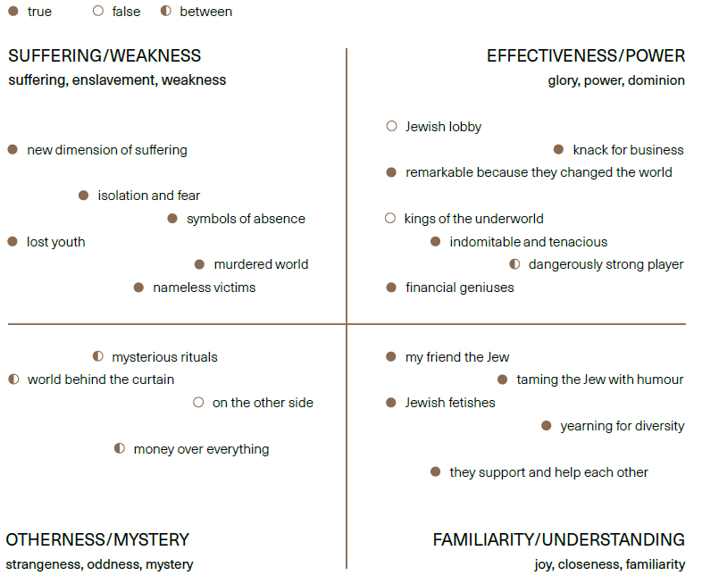

Key conclusions and communication recommendations from the analysis:
- CONCLUSION: The primary source of stereotyping is the false belief of non-Jews in their own considerable knowledge on Jews and the cultivation of a false, simplistic image of them as a homogeneous “alien group”.
The perceptions of those who did not identify as Jewish were firmly rooted in the past – lack of exposure to contemporary Jewish culture and its diversity.
- RECOMMENDATION: The key tool to combat negative stereotypes is to build among the public a rich, diverse picture of contemporary Jewish culture based on curiosity and empathy.
- CONCLUSION: Antisemitism provides a vocabulary for the negative description of other “alien groups” and minorities. In the context of the politics of disinformation (linked in the material analysed to, among other things, the COVID-19 pandemic and the war in Ukraine), well-established negative stereotypes against Jews become an effective tool for building fear and hatred of strangers.
- RECOMMENDATION: The fight against antisemitism not only can prevent discrimination against a specific group (Jews), but is also a key tool in the fight against disinformation, conspiracy theories and pseudo-science.
- CONCLUSION: At the same time, antisemitism is not a static whole or a fixed set. The cultural image of Jews themselves takes on new elements from modern, globalised channels that are used in other contexts to build up xenophobic rhetoric directed against completely different groups, becoming, for example, an important factor in the public’s increasing susceptibility to conspiracy theories.
Despite the high persistence of cultural codes, there are important differences between the perceptions shared by younger and older segments of the public.
- RECOMMENDATION: Communication must be carefully tailored to audience groups, with special attention to generational differences.

Introduction
Looking at graffiti on walls, listening to the chants of football supporters or following discussions on social media, it is not difficult to see that antisemitism remains a living part of our collective imagination. Surveys confirm this. The majority of Poles admit that they encounter stereotypes unfavourable to Jews. The issue is all the more serious because such obvious, explicit antisemitism is only the tip of the iceberg. Unconscious antisemitism plays an even more important role in our collective imagination. It is a set of perceptions, linguistic imprints, practices or scenarios that are not recognised as discriminatory at all by the very people who use them. Such prejudices easily become part of our “colloquial codes” – the invisible spectacles through which we look at the world.
A semiotic analysis commissioned by the POLIN Museum clearly shows that antisemitism in Poland today may not only be a practice of discrimination against a specific minority but also a universal code by which all kinds of “strangers”, “others” or “internal enemies” are described in contemporary Polish culture. Awareness of exactly what these codes look like may prove to be a key tool in the fight against disinformation and political manipulation.
This report has been produced in response to these challenges. It presents a map of images of the Jew in contemporary Polish culture, drawn from a variety of sources. It suggests which images and stereotypes are most prevalent in different age groups, considered true and obvious or, on the contrary, controversial. It shows which ones are perceived as hurtful by people who identify themselves as Jews. The report also includes communication guidelines drawn up on the basis of workshops with experts.
The document summarises the results of research conducted on behalf of the POLIN Museum of the History of Polish Jews, consisting of three parts: (1) a semiotic analysis, (2) workshops with experts and (3) focus group research.
The report has been designed for people whose main focus is not Jewish issues but who may come across a variety of cultural representations of Jews in their work. The document offers guidance for four main target groups in mind:
- politicians, local and state officials who shape the legal framework, have influence over public space, school curricula, etc.
- police officers, lawyers and people associated with the judiciary whose job may be to classify hate crimes
- opinion leaders, journalists and media professionals creating content and facing the challenge of selecting appropriate language
- educators, teachers, tutors and other persons influencing the public perception of Jews and national minorities
Representatives of all these groups face challenges that require quick and efficient navigation of cultural codes. Sometimes the difficulty proves to be the mere recognition of antisemitism, which can take many forms. Sometimes the task is to directly polemicise against antisemitism. At other times, as in the case of working with children and young people, the task is to develop, in the long term, an attitude of understanding, curiosity, sensitivity and respect that can pre-empt negative stereotypes, so that antisemitic discourse is not the first context in which young people come into general contact with Jewish topics.

Polish identity, Jewish identity
“Who are we?”, “Where do we come from?”, “What do we identify with?” – these are the key questions related to identity. Cultural codes and the invisible mythologies they construct provide us with a set of handy answers to these dilemmas. When an opinion about something is deeply internalised and becomes part of our identity, any criticism of it or attempt to nuance it is perceived as an attack on who we are, resulting in polarisation, frustration and anger.
The question of identity plays a dual role in the construction of social mythologies and cultural codes. Firstly, narratives or codes can directly answer the questions mentioned. Secondly, the set of perceptions and stories shared by a certain community (ethnic, national, generational, local, etc.) distinguishes it from others. “We” are those who know the same stories – we share a common language, recognise the same symbols or figures. “They” are those who tell themselves different stories, who conceive of the world differently.
In both of these dimensions, the identities constructed by cultural codes tend to be relational. This means that we define “our own” by contrasting them with those that are “strange” or “other”. Therefore, considering the identity of others and developing cultural codes to describe, recognise and label them plays a key role even in very homogeneous societies with minimal contact with otherness. Where there is no actual stranger, the imagined stranger has to be created on the basis of images drawn from imagination, cultural memory or external, imported narratives.
Jews, even if absent, remain a key element of Polish identity as a defining and complementary alien. Poles will often unconsciously define themselves as non-Jews.
This also applies to smaller identity groups. Thus, someone labelled a “Jew” can be, without any additional rationale, a supporter of a rival team or a representative of an opposing political stance.
The cultural codes describing Jews remain the default clichés used to describe the “new strangers” appearing in the cultural space. Polish racism and anti- Ukrainian or anti-Muslim stereotypes are largely constructed by old codes of antisemitism being pieced together into a new whole.
At the same time, the cultural image of Jews themselves can absorb new elements from modern, globalised channels used in other contexts to build xenophobic rhetoric directed against entirely different groups (e.g., conspiracy theories).

Stereotypes about an alien group
The focus group interviews conducted as part of the project suggest an important difference in defining Jewish identity as “own” and “alien”. When describing Jews, non-Jews focus on their otherness, and Jewish identity appears to them to be coherent and fairly easy to define even when there is no accompanying knowledge of that identity. Interviewees were keen to highlight features of the Jewish community such as seclusion or a tendency towards isolation. Meanwhile, for Jews themselves, their own identity is more capacious, and sometimes even difficult to define. Interviewees who identified themselves as Jewish were also aware of the stereotypical perception of their group by non-Jews. As one interviewee put it: “In most minds, the image of a Jew is that of a total Hasid. People can’t imagine, you know, that nobody looks like a Hasid nowadays”.

Jews seen through the eyes of non-Jews
- Non-Jews, when attempting to define Jewishness, focus̨ on aspects that emphasise the distinctiveness of this group, distinctive features.
- These are primarily aspects relating to religion or tradition: faith, rituals (e.g., Sabbath, koshering, circumcision).
- Another distinguishing feature of a Jew is his/her distinctive appearance: physical features (e.g., hook nose, large ears, whiskers, beard) or elements of dress (yarmulke, khalat, wigs for women).
- Sometimes a system of values and behaviour is mentioned: traditionalism, familialism, entrepreneurship.
- Some, especially the elderly, refer to the matter of inherited Jewishness (from the mother) as the “true” determinant of who is and who is not Jewish.
Jews seen through their own eyes
- According to Jews (especially older ones), the sign of being Jewish is ancestry, but understood not only literally, but also as the discovery of roots, respect for the past, closeness to Israel.
- An important element of identification is a sense of belonging to the Jewish people, sometimes built on a commonality of experience (ancestry: the Holocaust) and the burden of the legacy of the Holocaust.
- Jews are also defined by tradition, culture, both the knowledge of and the practice of it (e.g., koshering), and to a lesser extent by religion or language itself.
- For some interviewees, being Jewish is a certain distinguishing feature, sometimes a “superpower”: being different in a positive sense, stemming from the belief that they possess qualities such as an entrepreneurial spirit, perseverance, steadfastness.
- For some (especially older ones), being Jewish is about not revealing oneself, a certain secret, an identity handed down to them by their grandparents at the end of their lives.
- For younger people, to be Jewish is to be a citizen of the world, to be adaptable, open-minded.

This observation is in line with the state of research in fields like sociology or psychology. One’s own group is usually seen as more diverse than an alien group. The alien group is a kind of cultural magma – strangers are presented as a deluge, a flood. For this reason, stories about them are also accompanied by the fear that they might dissolve or disintegrate our identity, particularly if this identity is perceived as superior (collective narcissism) or if we construct it on the basis of (historical or contemporary) victim status (competitive victimhood).
The false belief that one’s own knowledge of Jews is high while being unaware of the cultural diversity of this group can be a significant source of stereotyping. At work here is the principle of the illusion of explanatory depth, i.e., the mistaken belief that one has knowledge that they in fact do not possess.
This false belief in one’s own knowledge leads to the formation of a simplified picture that does not add up to any meaningful whole, yet at the same time fills the gap, making us not ask questions because we believe we know. Research confirms the link between the illusion of explanatory depth and political polarisation and prejudice.
This creates a crucial cultural tension that generates antisemitic content. People who do not identify as Jewish feel that Jews are easily recognisable by a set of universal, highly distinctive characteristics, and at the same time (because these characteristics are the result of false perceptions) – they do not see Jews around them. This contradiction is the bedrock on which ensuing stories grow: about hiding, secret conspiracies and associations, identity changes and masks, as well as the demand for Jews to “reveal themselves”. Ways of “identifying Jews” and various proposals for “labelling” them become a key element of antisemitic cultural codes.
This suggests that one of the key tools in the fight against stereotyping is to shatter the illusion of explanatory depth by making the audience positively aware of their ignorance, thus building an attitude of curiosity, pointing out the variations within the “alien group”. In this way, strangeness becomes a terrain for exploration rather than a homogeneous territory lying outside of “our own”.
This seems all the more important as the same mechanisms can be observed in attitudes towards other “alien groups”. Prejudice against Jews provides a universal language of fear and dislike that is then projected onto other groups – in recent years, for example, Ukrainians or migrants from the Middle East.

Generational differences
Age appeared to be an important factor in differentiating both the level of knowledge and the sharing of perceptions about Jews:
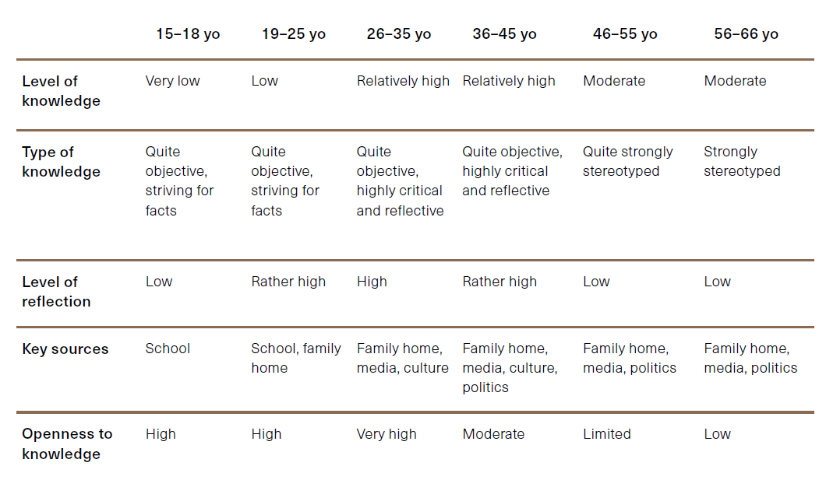

According to younger Jews
- identity often understood as part of legacy from grandparents/great-grandparents;
- more often unequivocally positive emotions related to being Jewish: curiosity, openness; much less often tensions (like shame, fears, burden), sometimes neutral;
- for many, the discovery of their “Jewishness” coincided with a phase of defining themselves as a human being (maturing, building relationships, etc.), and became a spark in developing an identity, understanding oneself;
- being Jewish understood as a capacious identity, multidimensional (tradition, culture, language, religion, as well as specific traits or “superpowers”), does not exclude simultaneously defining oneself as a Pole;
- an identity that is part of the broader phenomenon of openness to different cultures and appreciation of diversity.
According to older Jews
- identity often understood as the dominant legacy (sometimes: burden) from parents/grandparents,
- more often ambivalent feelings around being Jewish: curiosity, closeness, community, as well as fears (due to potential exclusion, burden of history, entanglement in the past and politics), lack of neutrality – strongly felt identity;
- for some (the oldest), identity is also composed of the almost tangible fears of their ancestors and their unimaginably difficult experiences (such as the Holocaust, antisemitism, the experience of 1968, etc.);
- being Jewish understood as a great need to cultivate (selected) traditions, for some the need to discover roots, to cultivate the memory of the past, to discover traces of ancestors; for some a stronger identification than being Polish.
This means that communication on this subject must be tailored to specific age groups and address their needs, as well as their level of knowledge.

The code map
Part of our everyday experience is the feeling of uncertainty associated with having to meet new people, especially those from other social groups. Cultural codes tame this uncertainty, providing us with ready-made scripts for action or “maps” of situations, but often also – as mentioned earlier – leading us astray into stereotyping.
The main objective of our project was to map the most widespread cultural codes relating to the figure of the Jew. These codes are tools for synchronising collective perceptions and emotions. They are scattered throughout cultural works, the daily press, conversations. Some are top-down (e.g., based on the findings of academics or derived from propaganda), while others are bottom-up (growing out of vernacular culture, table talk being a typical medium).
Using semiotic tools (see Appendix 1 at the end of this report) to analyse a wide corpus of diverse sources, we have attempted to create a map of the most prevalent codes. In the subsequent stages of the project, the recognisability of individual codes and the subjective assessment of their veracity among Jews and non- Jews were verified in the course of workshops with experts and in focus group surveys.
The first stage of the semiotic analysis was to identify two dominant fields of meaning, building the fundamental cultural opposition determining the image of the Jew in contemporary Polish popular culture:
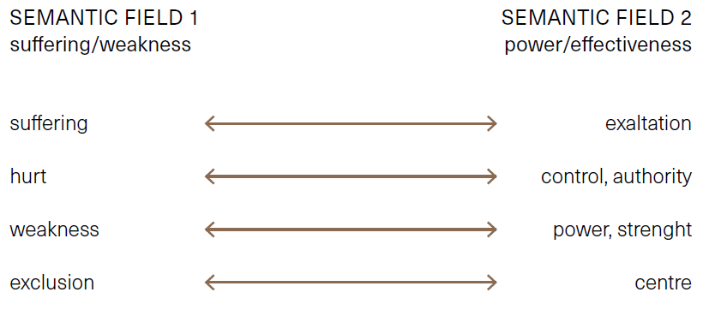
This is the opposition between images of the Jew associated with suffering (largely based on images of the Holocaust) and those situating the Jew in a position of exaltation, control, power. This strong duality builds up a tension or even a rupture in the social perception of Jews and becomes a source of paradoxes that will be explored in the following stages of the study.
A semiotic square was then constructed on the basic cultural opposition thus identified. This operation consists of assigning a logical opposition to each semantic field, resulting in four related fields .
After the logical categories were superimposed on the collected material, proposals for two further semantic fields emerged:
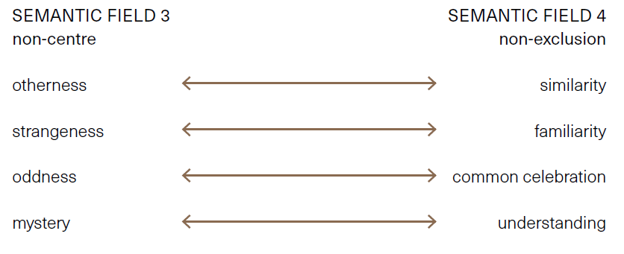
We thus obtain four main semantic fields:

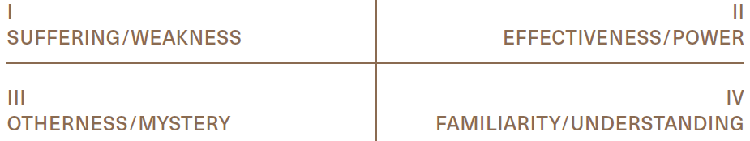
The four semantic fields delineated in this manner can also be ascribed with clearly defined spatial categories:
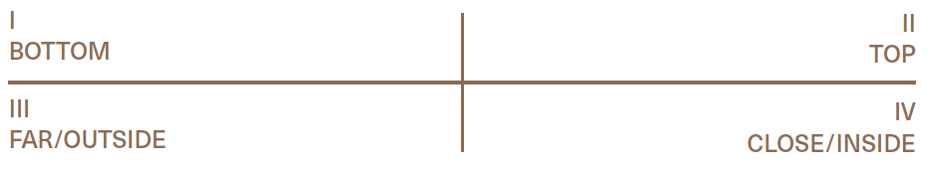
Then, within each of the “quadrants” of the semiotic square, several coherent codes were extracted, making up a total of 22 very diverse images of the Jew and Jewish culture:
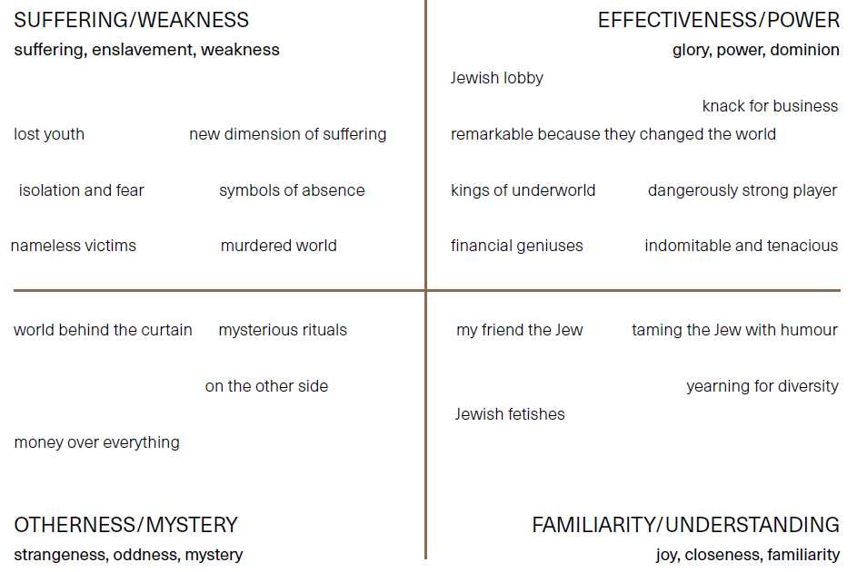
Each of these codes is associated with a distinctive set of images, motifs or figures.

Perception of codes as true/false
In the focus groups, we asked people who identify and those who do not identify as Jewish, which of the codes indicated in the semiotic analysis they consider “true”, which they consider “false”, and which they consider to lie somewhere “in between”:

PERCEPTION OF JEWS: AREAS (ACCORDING TO NON-JEWS)
With the reference to the semiotic analysis
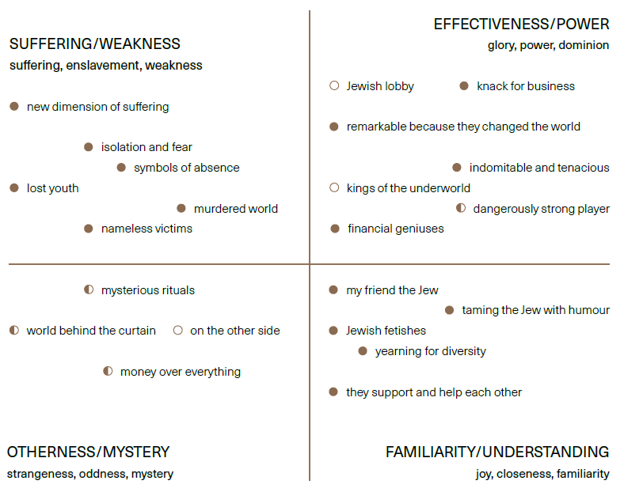

PERCEPTION OF JEWS: AREAS (ACCORDING TO JEWS)
With the reference to the semiotic analysis
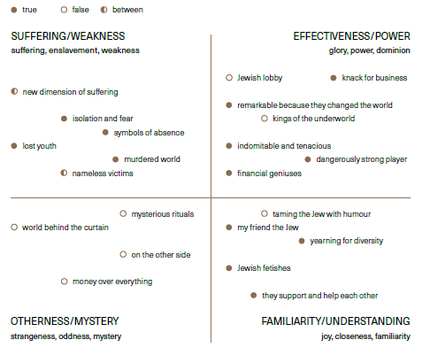
Both groups unanimously reject as hurtful the code “kings of the underworld” and associations with criminality, as well as codes associated with radical alienation or hostility between Poles and Jews. This seems to be an interesting track. Both of these codes have a high “surface antisemitism” – they seem on the surface to be very negative. However, on closer analysis, both (especially the “kings of the underworld” code, associated with, among other things, stories about Jewish gangsters of the interwar era) turn out to be much more nuanced and endowed with positive potential for the construction of a complex, engaging, non-stereotyping image. Perhaps their rapid rejection and recognition as false, especially by a group not identifying as Jewish, stems from the fear that by accepting a code linking an alien group to criminality, they would appear prejudiced. Meanwhile, seemingly affirmative codes and images, such as the “Jew with a coin”, on the surface expressing praise for Jewish resourcefulness or thriftiness, are recognised as “real” or “credible”.
Those who do not identify as Jewish base their perceptions more on the “suffering, enslavement, weakness” quarter. This may be explained by a lack of contact with the contemporary Jewish community and its culture, and by building perceptions of Jews solely on sources relating to history, including in particular the enduring popularity of Holocaust literature.
Non-Jews see the code word “dangerously strong player” as a damaging, untrue stereotype. It is a set of perceptions relating to the strong Jew and to the modern state of Israel as a military and technical power. People who identify as Jewish perceive this code positively. It seems that this discrepancy, too, may be rooted in the historical entanglement of the Polish collective imagination and in the close association of the image of the Jew with the semantic field of “suffering, enslavement, weakness”.
In contrast, the quadrant “joy, closeness, familiarity” is perceived as credible and positive by both groups, potentially providing a good field for bridge-building. The only significant difference concerns the code “taming the Jew with humour”, which those who identify as Jewish see negatively.
Differentiation by age also plays an important role. Older respondents had weaker associations with steadfastness and wisdom, while tensions and fears around matters of finance grew. Perceptions of the otherness of Jews and the negative connotations associated with this otherness also increased.
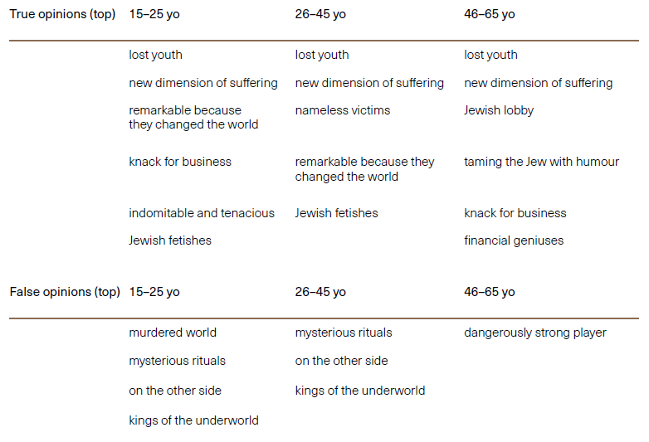

Detailed analysis of the code map
The 22 codes initially identified were then compressed into eight areas, also taking into account the suggestions and associations of the interviewees in the focus groups.
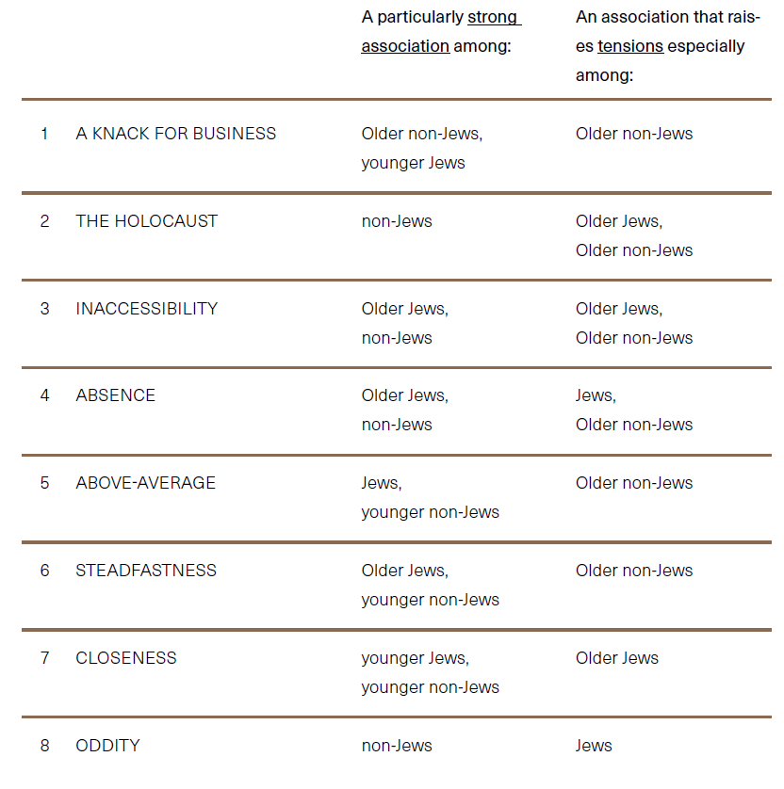
Each of these areas was then discussed in detail in focus groups.

Area 1. A knack for business
THE MOST IMPORTANT MOTIFS: a business acumen stemming from knowledge, as well as religion or history (in connection with, for example, involvement in trade); harbouring a great respect for money; meticulousness in accounting (“Let us love each other like brothers, let us count like Jews”); for some: stinginess (symbol: a Jew with a coin – for luck in finances, and proof that a Jew “keeps an eye on money”); for few: flaunting one’s wealth, being influential, owning possessions.
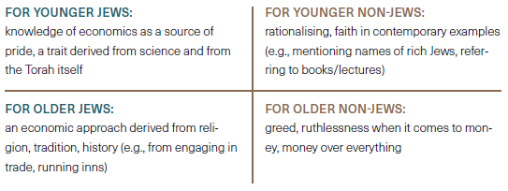
GENERAL LEVEL OF TENSIONS: MODERATE
TENSIONS: getting rich in sometimes morally questionable ways (e.g., fraud, lack of selflessness, demanding a fee for, e.g., help), greed manifesting itself in the recurring theme of compensation and the desire to claim assets, putting money above everything else (e.g., above “human honesty” or “selflessness”). Sometimes: stinginess despite a financially privileged position.
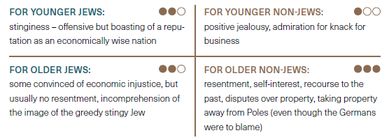

Area 2. Holokaust
THE MOST IMPORTANT MOTIFS: A huge tragedy, an unimaginable crime, and also a lesson for others – the fate of the Jews as a warning of what hatred can lead to, of what cruelty humans are capable of. Macabre stories of death camps, the killing of children, unfathomable plans to exterminate a nation, unfathomable practices (e.g., making soap from the remains of people).
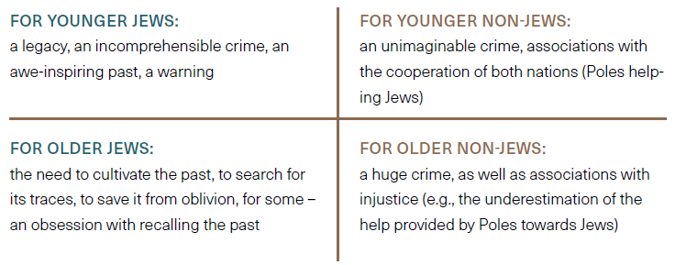GENERAL LEVEL OF TENSIONS: MODERATE
TENSIONS: The Holocaust as a politicised, difficult, emotionally charged topic, not only evoking sympathy for the victimised people, but also requiring sensitivity and political correctness. For some non-Jews, a justification used by Jews in expecting special treatment (immunity, extra-sensitive treatment, irritability about the past). Accusations against Jews for focusing too much on the Holocaust and validating their privileges with the wrongs suffered in the past.
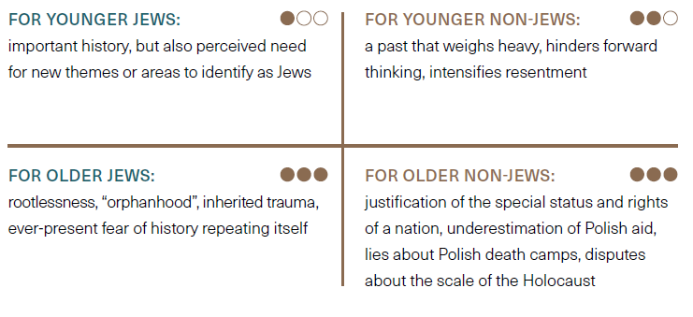

Area 3. Inaccessibility
THE MOST IMPORTANT MOTIFS: A focus on their community, traditions, customs, keeping others out of their world. For some: clustering around shared values or experiences particular to that group (the Holocaust). For others: isolation, invisibility, not making themselves known, shying away from publicity, from being noticed. Positive aspect: mutual support within the community, loyalty, sometimes favouring “their own”.
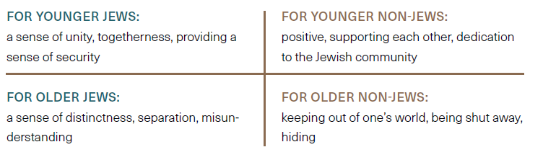
GENERAL LEVEL OF TENSIONS: LOW
TENSIONS: Resulting mainly from the veil of mystery that surrounds Jews. A high degree of curiosity (especially among younger non-Jews) and also suspicion (especially among older non-Jews). Envy resulting from observing Jews supporting each other in contrast to Poles, who are seen as incapable of helping or supporting each other.
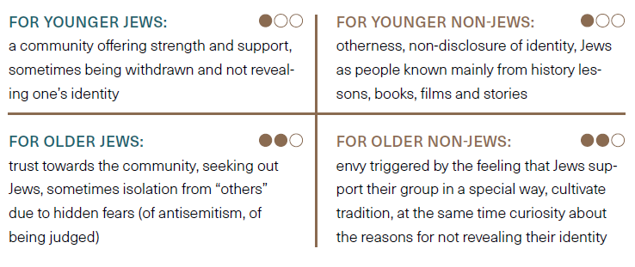

Area 4. Absence
THE MOST IMPORTANT MOTIFS: Jews as absent, as a social group, now invisible, belonging to the past. A focus on traces of the past, on past glories in contrast to the presently smaller numbers (in Poland). For some: Jews as an uncommon community, appearing festively, for specific occasions (e.g., Jews’ trips to memorial sites). Lack of everyday, ordinary, neighbourly presence.
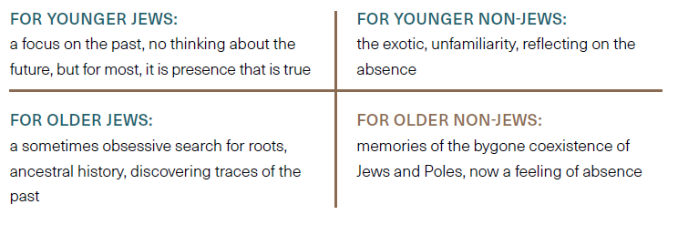
GENERAL LEVEL OF TENSIONS: MODERATE
TENSIONS: nostalgia for a past that cannot be rebuilt, for past coexistence and “normal” functioning, a sense of injustice. For younger people, the need to positively break the narrative of absence and focus on the traces of presence, on learning about Jews, their traditions and culture.
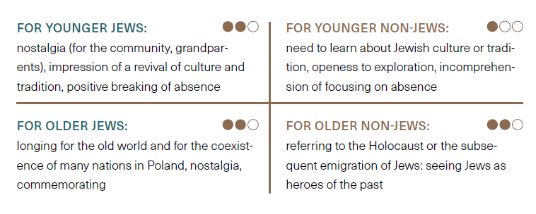

Area 5. Above-average
THE MOST IMPORTANT MOTIFS: Jews as a nationality endowed with outstanding intellect and wisdom. By some justified by religion, tradition, learning from the Torah, conscientiousness, respect for spirituality, self-development, philosophical thinking. For others, wisdom acquired through centuries of experience of adversity (such as expulsions, persecution, ghettos, the Holocaust). Moreover, the historical, as well as contemporary, strength of influence in the world, in different branches, in different positions, is admired. For some, Jews evoke envy, suspicion of deal-making, exploitation of others, acting superior.
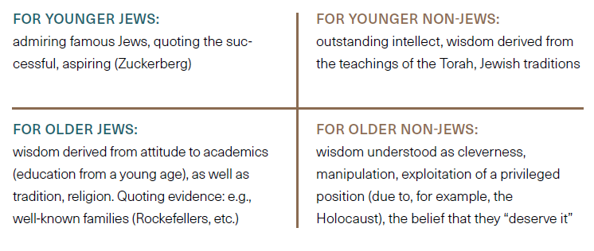
GENERAL LEVEL OF TENSIONS: LOW
TENSIONS: For most, a low level of tension – a rather positive perception of Jews as smart people who can at best be envied for their power of influence or entrepreneurship. For some, exaltation, using their difficult history to achieve a special status or gain a head start.
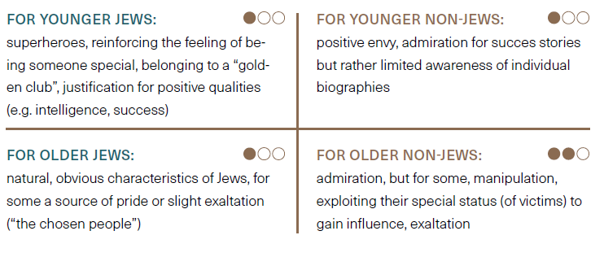

Area 6. Steadfastness
THE MOST IMPORTANT MOTIFS: Jews as a tenacious, indomitable nation, with great fortitude, a will to survive. To some, the unimaginable strength and determination of the Jews as evidenced by the nation’s survival and rebirth with success despite the experience of the Holocaust. A nation that today has a strong state, famous for its excellent intelligence, military and courageous citizens (e.g., military service also for women).
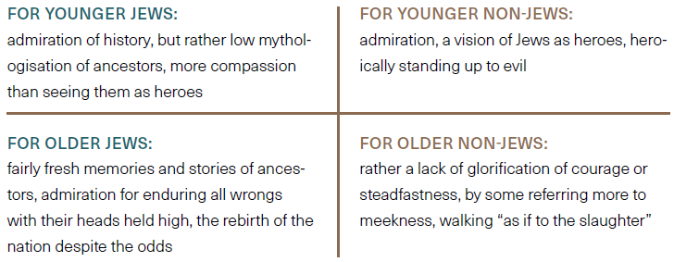
GENERAL LEVEL OF TENSIONS: LOW
TENSIONS: for most, a lack of tension, but rather admiration and sympathy for a nation that has suffered tremendous harm and yet has rebounded with success. Appreciation for a nation that has created a state and a formidable army. For some respondents, the rebirth of the nation is not so much due to determination, but rather to the exploitation of “victim” status and the leniency of others – an undue enjoyment of privileges.
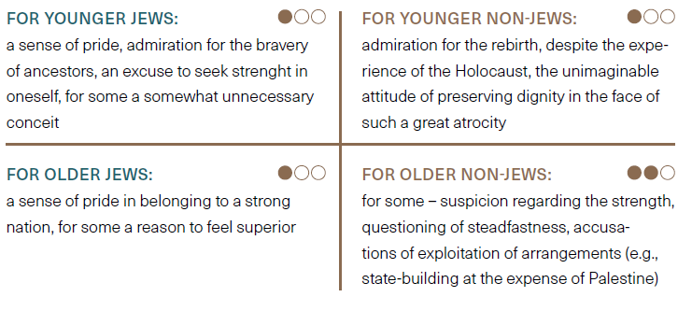

Area 7. Closeness
THE MOST IMPORTANT MOTIFS: The Jew as “a person like any other”, with a similar system of values, views, etc. Some younger non-Jews simply see Jews among us as the same, with no expectation of their being uniquely different. For some (from larger cities) a noticeable fashion for Jewishness (cuisine, traditions, TV series, etc.), which for some younger Jews means that being Jewish can be personally enriching, can be “sexy”.
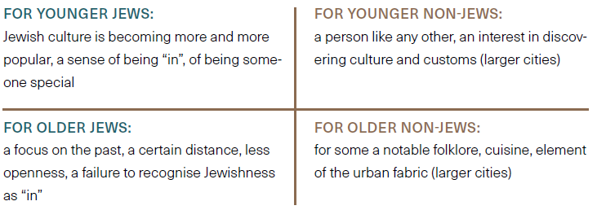
GENERAL LEVEL OF TENSIONS: LOW
TENSIONS: sporadic, resulting from a tendency to folklorise Jewish culture or tradition, without a real openness to getting to know Jews or engaging in a dialogue (according to older generations of Jews)
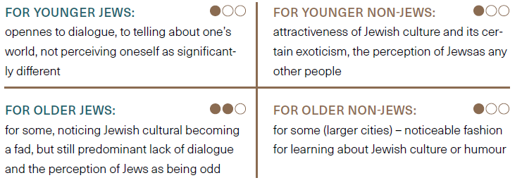

Area 8. Oddity
THE MOST IMPORTANT MOTIFS: Jews as a strange nation, an outlier due to the distinctiveness and mysteriousness of their customs. For non-Jews, a misunderstanding of the origins of certain practices, exoticism (e.g., Sabbath, keeping kosher, circumcision). There is a deliberate search for otherness, a perception of Jews as distinctive in appearance (e.g., challah, sidelocks, yarmulkes). For Jews, an otherness that enriches, is interesting and unrestrictive
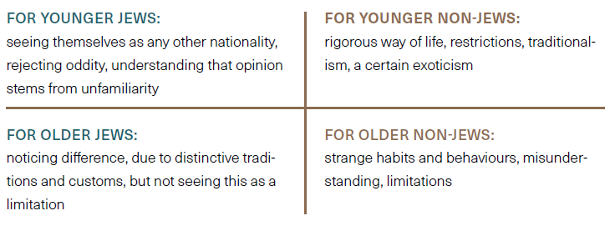
GENERAL LEVEL OF TENSIONS: MODERATE / LOW
TENSIONS: According to Jews, these arise from non-Jews’ lack of openness to learning about their customs and traditions and a lack of willingness to understand. Exaggerating their strangeness, looking for evidence that Jews are odd, different (inexplicitly – excluding Jews is justified because they don’t fit in with the majority, they excessively emphasise their difference, they are controversial). For Jews, the opinion of their oddity is painful, although for some younger ones it is understandable. The lack of openness of Jews themselves to dialogue leads to self-exclusion.
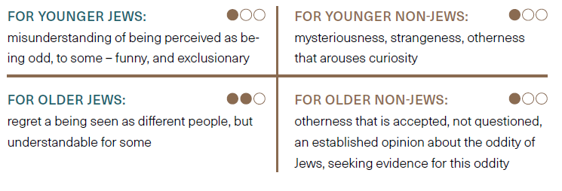

The most popular antisemitic narratives
The POLIN Museum of the History of Polish Jews uses the International Holocaust Remembrance Alliance’s (IHRA) working definition of antisemitism. The alliance unites governments and experts from around the world to strengthen, develop and promote education, remembrance and research on the Holocaust during World War II. A working, non-legally binding definition of antisemitism was formulated as a result of the deliberations of representatives of 48 countries, united in the IHRA on 31 May 2016. 31 countries adopted it immediately, some – such as the Czech Republic – introduced it into their legal systems.
It reads:
“Antisemitism is a certain perception of Jews, which may be expressed as hatred toward Jews. Rhetorical and physical manifestations of antisemitism are directed toward Jewish or non-Jewish individuals and/or their property, toward Jewish community institutions and religious facilities.”
During the International Forum on Holocaust Remembrance and Combating Antisemitism, held in October 2021 in Malmö, the Polish Deputy Prime Minister, Piotr Gliński, confirmed Poland’s adoption of the definition and its implementation in the area of public action or education. In the same year, the European Commission published the “EU Strategy on combating antisemitism and fostering Jewish life“ and included in its recommendations, inter alia, the implementation of the IHRA definition in EU Member States.
At the moment, the definition is being incorporated into a number of Polish documents aimed at combating antisemitism in the public space, e.g., plans to combat hate crimes in the police or guidelines on education.
Despite Poland’s small Jewish community today, antisemitism is unfortunately constantly present in the country, with many people using antisemitic stereotypes or antisemitic rhetoric to insult or discriminate against not only Jews but often all those who for any reason are perceived as alien or different. Antisemitic linguistic clichés have almost been “imprinted” into the Polish language and are very often used semi-consciously or unconsciously. This phenomenon is present in almost all social and age groups. As such, it is extremely dangerous as it fosters polarisation, discrimination and exclusion of individuals or entire groups (such as refugees, migrants, ethnic and religious minorities, members of sexual minorities). This is why it is so important to combat this phenomenon in Poland, and the POLIN Museum feels particularly obliged to do so. Accepting the presence of antisemitism in the public space opens up the possibility of other false and hateful content appearing therein as well, and leads to desensitisation to the stereotyping of not only Jews but also other minority groups, leading to exclusion and impairing the functioning of society at large.
It is particularly important to eradicate antisemitic clichés from the Polish language at the stage of school education of children and young people, as this offers a chance of preventing their transmission and dissemination among future generations of adults. Responsibility for this lies in the home, as well as in schools, the media, sports circles, etc.

The analysis
As part of our research, we analysed a large body of newspaper articles and tweets in search of dominant narrative threads. These can be thought of as building blocks – ready-made elements from which narratives of an antisemitic nature are then assembled. Such elements can be both storytelling devices (repetitive events, plot twists) and formal elements related to the narrative form itself – characteristic linguistic registers (e.g., sublimity or archaisation), expressions, metaphors, rhetorical tropes. The key factor in identifying a given element as significant was its repetition in the body of texts under analysis.
Dominant narrative tropes:
- Belief in the existence of a “Jewish lobby”
- A feeling that Jews create a negative image of Poland
- and Poles
- A belief that Jews do not show proper gratitude to Poles
- A perception of Jews as foreign agents
- Attributing blame for the misfortunes of the Jews to the Jews
- themselves
- Describing Jews as the rulers of the world
- Calls to “fight Jewry”
- Describing “Jewry” as a disease and sign of corruption
- A belief that Jews make money from injustice
- Calls to learn from the Jews

Belief in the existence of a “Jewish lobby”
This thread of antisemitic potential is linked to the contemporary actions of the state of Israel and the global Jewish diaspora. It relates primarily to the claims that the Jewish community makes on pre-war property.
In this line of thought, the “individual” greed attributed to Jews as a character trait and cultural trope in traditional Polish antisemitic discourse is translated into the language of institutions, politics, law and economics, and thus inscribed in the global order of dependency, centre-periphery relations or sovereignty.
The number 447, referring to a US Senate resolution (Justice for Uncompensated Survivors Today Act of 2017), has become a key sign of this thread in recent years. The term ‘Holocaust enterprise’ is also frequently invoked in the same context.
Phrases related to pressure, manipulation, as well as greed and deviousness are distinctive here: “Jews demand”, “Israel keeps demanding”, “ruthless pressure”, create a sense of resentment towards Jews in general.
Texts of this nature get a large response in the form of negative comments. Among these, there are also voices calling for demands against Jews, i.e., proposals that Jews should be the ones to pay reparations to Poles.
Within this thread, there are also prominent texts that draw attention to the negatively assessed practices of the contemporary Israeli state. Terms such as “Zionist racism” are used, based on a reversal of well-recognised Holocaust narratives and perceptions in Polish society.

A feeling that Jews create a negative image of Poland and Poles
The trope is a reaction to real and imagined accusations made by Jews against Poles. It is a kindred thread to the “Jewish lobby” trope described earlier. The key element of both is ingratitude, described in more detail later as a separate theme.
A tone of outrage expressed by terms such as “shocking allegations”, “outrageous article”, “complete nonsense”, “outrageous speech”, “perfidiously written” is evident in the headlines and the texts themselves.
A key element of the narrative under discussion is the vision of Jewish “appropriation” of the Holocaust (or, more broadly, the discourse of suffering, the role of victims, World War II, or indeed of history as a whole). In the light of the narratives described, Poles have the right to feel marginalised, underestimated, overlooked or even – as mentioned earlier – denigrated and falsely accused.
Jews are attributed with “propaganda”, “disinformation” or – to use the currently popular terms - the creation of “fake news”.
Narratives using this theme suggest that facts and figures inconvenient to the Jewish vision of the past are passed over in silence or even erased from history. Such figures are described as “inconvenient” or “illegitimate”. In this way, antisemitic theories plug into the recently popular argument about “cancel culture”, culture wars and political correctness.
Thus, Jews become “rulers of the world” as a “new protected species” to which “everyone must bow down”. Antisemitism can therefore appear as an act of courage, of throwing off the yoke, of liberation.

A belief that Jews do not show proper gratitude to Poles
This trope focuses on ingratitude as a key character trait that defines Jews both as individuals and as an institutionally organised collective. The premise of this thread is the gratitude that Jews supposedly owe to Poles. Since they have been guests on our lands for centuries, treated well, as equals, and have experienced help from Poles on an unprecedented scale in difficult times, a socially normal response would be gratitude, which should be expressed on both a material and symbolic level. Meanwhile, the Jews – as described earlier – demand the return of their property and also speak ill of Poles, which, in the light of the narratives analysed, constitutes a flagrant violation of the principle of reciprocity and a retribution of evil for good.
Referring to codes from the field of alienation, Jews are described here as not sharing our cultural norms of gratitude.
In a manner characteristic of many Polish antisemitic narratives, individual events are juxtaposed with historical material within the interpretative practices typical of the “politics of eternity” (Snyder), and thus inscribed within the “eternal laws of history”.
A key motif in this thread is the “stab in the back” (a metaphor often also illustrated literally in the visual layer). Appearing are expressions such as “you give them a finger, they’ll bite your hand off” or “instead of thanking Poland...”. This theme often develops into the image of Jews as parasites – culturally and biologically alien entities preying on the ethnically homogeneous tissue of the Polish nation. Metaphors of “sucking blood” appear, relating to the medical metaphor discussed in more detail in one of the subsequent tropes.
Within this one, Poles are characterised by a good heart and generosity verging on naïveté. The antidote to this malady should be a “healthy national egotism”, which, interestingly, Poles could learn from the Jews.
It is in this thread that the belief in the anti-Polishness of the Jews finds its footing, which becomes a looking-glass to reverse the accusations of antisemitism against Poles in the collective imagination. Antisemitism itself, in turn, occurs to be a key tool in the Jewish “reversal of history” and politics of accusation.

A perception of Jews as foreign agents
This trope collects motifs related to Jews as foreign agents of influence in Poland and other countries. In this context, Jews are readily linked to Freemasonry, global conspiracies, and the global leftist movement.
The popular topos of a “Jewish Communism” [Żydokomuna] finds one of its forms of expression precisely within this theme. Here, Jews turn out to be internal enemies – agents of the Left, dismantling the social order in the nations that have “hosted” or “taken them in”. Evidence of this in the texts analysed included Marx’s alleged deep connections with Jewish mysticism.
ALIENATION is the dominant code here, although the conspiracy elements included in this thread sometimes also rely on motifs of SUPERIORITY.
Jews are described here as people who “meddle in affairs that are not their own”. They form a hidden (parallel to the official) state structure. They are often accompanied by terms related to intelligence or espionage, such as “agent”, “leading officer”.
The theme has recently become extremely relevant in the context of the war in Ukraine. Jews are linked both to Russia (e.g., the logo of the Law and Justice party is redesigned by adding a yarmulke, accompanied by the slogan “ruska onuca” [Russian footwrap – pejorative for a Russian collaborator or agent – from the translator]) and to Ukraine (use is made of Zelensky’s Jewish background and the Khazaria motif (described in more detail further on).
Key ministers, the prime minister, bankers – anyone who happens to donate money to Jewish institutions, does not openly oppose the return of property or generally does not meet the high standards of “healthy national egotism” – are portrayed as Jewish.
A key motif emerging in this context is the “exposure” or “unmasking” of the Jewish descent of individual public figures.

Attributing the blame for the misfortunes of the Jews to the Jews themselves
In this trope, Jews are presented as the driving force behind everything that is wrong in history. It is a strand strongly imbued with the discourse of memory, always placing current events in the seemingly obvious context of history and willingly reinterpreting the “canonical version of the past”, which in this context becomes symbolic of the enslavement of minds.
Following the line of reasoning highlighted in the previous threads analysed here, the Jews, through the use of propaganda manipulation and institutional pressure, have managed to construct a false image of history, within which they become the winners in the global “competition of victims” (being the ones who suffered the most). A key element of the theme presented here is thus to show that Jews are not as innocent as they would like to portray themselves. In this way, the blame is lifted from the ethnic Polish community with which the authors of the analysed texts identify.
This discourse portrays Jews as oppressors rather than victims. It is mainly considered in a historical context, going back to Jewish misdeeds in the 10th century, the Swedish Deluge, the Soviet Revolution and so on. This is an interesting form referencing, in a broad sense, the guilt of the Jews as those who contributed to the crucifixion of Jesus. The Jews thus “collaborated”, “traded slaves”, “committed crimes”.
A recurrent motif within this thread is the reinterpretation of the pogroms against Jews. This is mainly to deny the role of Poles as perpetrators and sometimes even to deny that certain pogroms took place. The main terms are “lying about Poles”, “unfounded accusations”, with the term pogrom often written in inverted commas.
An interesting element of this thread is the new use of the argument about the “disintegration of the state”, familiar from Timothy Snyder’s Black Earth or the early works of Jan Tomasz Gross (Revolution from Abroad), among others. For authors such as Jan Marek Chodakiewicz, who regularly publishes in Tygodnik Solidarność weekly, the pogroms are the result of the destabilisation of the situation in Europe, which was brought about by the Jews themselves, usually blinded by Marxist ideology. In this way, pogroms against “good Jews” become the fault of “bad Jews”. This guilt can also be extended to contemporary Marxists or supporters of the Left.
Sometimes pogroms are described as a “normal” historical mechanism, and not necessarily as an outcome of exceptional hatred toward Jews. In the texts analysed, for example, we read that “the pogroms were mainly due to the dynamics of revolution and counter-revolution, and therefore primarily to the breakdown of law and order”.

Describing Jews as the rulers of the world
This is one of several “geographical” themes present in the analysed body of texts, i.e., primarily serving to explain the world through the construction of a certain space. Such a spatial model explains reality by showing the mutual positioning of different characters or ethnic groups by inscribing them in axes of higher-lower, internal-external, centre-periphery.
This trope places Jews at the centre of the contemporary world. However, because they maintain their alienated status (the Jew as cultural and political outsider), the world thus described becomes a “backwards world”, in which anomie has replaced norms. It is a world of anti-culture and anti-values, in which those who should be at the bottom have found themselves at the top.
It is also a discourse in which Jews are linked to other conspiracy theories. Sometimes it is a link through context, e.g., “flat-earthism, Jewry, Freemasonry, reptilians”, and sometimes it is a conspiratorial search for links like a “satanic bloodline”. Frequent elements are assertions and judgements with a question mark. Of course, the key terms are “power”, “world dominion”, “conspiracy”, “hidden-revealed”.
A key theme of this trope is a sense of ownership, or lack thereof. Jews “own the whole world”, in particular the media and big companies. At the intersection of these categories is social media; Jewish power thereover particularly igniting the imagination.
One expression within this thread finds the topos of Jewish Communism [żydokomuna], which we have broken down into several separate motifs. It seems that żydokomuna, in one of its senses, can today mean the general global left, from the Democratic Party in the USA to radical communist movements. In the material analysed, enjoying particular interest is Leftism of the Brussels variety.
An important element of the thread is the abolition or dilution of borders by Jews. All international projects, the opening of borders and the refugee movement itself, become elements of a Jewish conspiracy. This makes sense when Jews are seen as a wandering people, whose nature is precisely to mix, to blur clear ethnic divisions, to falsify identities and so on.
This theme is also alluded to in many stories about Jewish Communism, situating it as a cohesive movement or even organisation against the background of a broad historical panorama.
Key motifs and terms within this strand are “conspiracy”, “network” or “connections”. Characteristically, it places Jews “at the centre”, “in the middle”, “on top”, as well as “behind the curtain”, “behind the veil”. Geographical terms such as Polin, Khazaria or New Jerusalem appear. At the same time, typical Jewish behaviour is to abolish, open or erase borders, making them a group that threatens the clear division of the world into geographical (national) identities.
A variation of this theme are the lessons of “secret geography”, where the key words are the names of historical and future Jewish imperial projects: “Polin”, “Khazaria”, “New Jerusalem”.
The scale of geographical and imperial projects here extends over millennia, referring both to ancient history (often fictionalised) and to plans looking many generations ahead.
A key element of the latest antisemitic content has become the identification of Ukraine with Jews. If we consider Ukraine to be the “new Khazaria”, then the whole ongoing war takes on a new meaning and becomes just another vestige of a global Jewish conspiracy.
If Ukraine is a Jewish outpost, then any mutual friendly gestures between Poland and its eastern neighbours are in fact vassal gestures to the Jews and are interpreted as submission.
The war in Ukraine has also revived the myth of Polin – a Jewish state either planned on the territory of present-day Poland, or for centuries secretly functioning in parallel to the official circulation of power and money.
The motif of working for the Jew is important here – in Polin, Poles have a subordinate status, the status of slaves. A reference to the motif of the Jew parasite – drainage, exploitation, blood sucking.
An important variation of this theme is the portrayal of the modern world as a “Jewish civilisation”. Referencing the theses of Felix Koneczny, Oswald Spengler or the still popular works of Samuel Huntington, the authors of the texts in the analysed body of work were keen to talk about the “hostile takeover” of the entire world by the “Jewish civilisation”.
What we have here – typical of antisemitic discourses – is a paradoxical construction. Here, the Jews are “alien” to the global civilisation of the West, representing a culturally and religiously different element, but at the same time they have seized power over it, so that the technological achievements of Europe and the USA now serve to perpetuate Jewish domination of the world.
This discourse is similar to the previous one, which links Jews to conspiracy theories. However, here it is definitely dominated by analyses and studies that give the feeling of a well-documented scientific argument or reportage (journalistic investigation) that is meant to “awaken” the reader and evoke terror in them.
These are texts describing the “Jewish civilisation” as a cohesive supra-state entity characterised by a specific ideology, goals and principles, as well as the organization and methods of this civilisation.

Calls to “fight Jewry”
A text of this category is something of a proclamation or manifesto urging to fight Judaism. Although present-day phrases of this kind also exist, the main core here is made up of quotations and elaborations of phrases from the past. They refer to Polishness and Christianity as endangered values, but also as pillars in the struggle. Typical of the manifestos are exclamation marks and exhortations such as “arise” and “we will win”.
A solemn, pathetic style is characteristic of this trope. It combines well with the vision of a world overrun by Jews and the omnipresence of Jewish agents as “internal enemies”. Constructed in this manner is an attractive identity of the antisemite as someone “going against the grain”, a participant in the rebellion against the Jewish empire ruling the world.
The theme links well with almost all the other ones described in this report, giving them pathos and a clear “call to action”. It is worth noting that the form of the imperative completely removes the problem of the logical value of the statements (true/false).
In the phrases quoted by this group, expressions such as “I call on” and quotations from “antisemitic classics” often recur. They are characterised by an archaisation of language, which is intended to emphasise both the solemn (in the authors’ intention) style and the eternal and perpetual nature of the conflict (e.g., defining one’s own community as a “Piast nation”).

Describing “Jewry” as a disease and a sign of corruption
This trope is one of the classic topos of antisemitism. Jews are connoted with disease, corruption and decay. The biological metaphor references both “our own” people or civilisation (which have their own life, grow, develop) and to “outsiders” – Jews depicted as pathogens, agents of decay and death.
This is a theme very much embedded in the codes of SUFFERING we identified earlier. Jews become identified with material and corporeal lows, the sphere of disease, corruption, pathology and decay.
Phrases in this group use terms such as “zażydzenie” [invermination with Jews – from the translator], “żydostwo” [pejorative use of the term Jewry – from the translator], and metaphors of disease, decay, corruption, often in juxtaposition with the notion of “civilisation” or “culture”.
The “Jews as a plague” theme has recently gained new means of expression following the COVID-19 pandemic, which is often interpreted as a “global Jewish conspiracy” in the analysed body of texts. Similar imagery has been extended to monkeypox. Thus, authors speak of a “Jewish pandemic”, drawing attention not so much to the disease itself but to the institutional dimension of the fight against it (masks, lockdowns, vaccines), for which Jews are allegedly responsible.
Against a backdrop of such an image, the global Jewish diaspora itself is compared to a pandemic infecting all the nations of the globe.

A belief that Jews make money from injustice
This theme portrays Jews as driven solely by material interest and desire for profit. Because of their ruthlessness and global influence, they are particularly keen to make money from human misery. They deliberately cause crises and misfortunes (epidemics, wars, high prices) in order to profit from unstable situations.
This theme combines elements of SUPERIORITY and ALIENATION. Many of the texts analysed highlighted the ruthlessness and disloyalty of Jews who are willing to monetise the misfortune of their benefactors and even members of their own community (other Jews).
In the antisemitic imagination, the theme of profiting from injustice is closely linked to Jewish politics of memory and the motif of the “Holocaust enterprise”.
This theme is often combined with the Jewish plague theme described above, particularly in the context of COVID-19, because, as we read in texts representing this strand, “for Zionists the coronavirus is also a business of selling ‘human parts’”.
In recent texts, the theme of profiting from harm also recurs in the context of the war in Ukraine. Jews are accused of having caused the war, thus taking the responsibility off the Russian aggressors. It is worth keeping this theme in mind, as it is very likely to become an important axis of Russian propaganda and disinformation in Poland.
The whole armed conflict is also often portrayed as part of a wider plan to create a Jewish state in Central Europe (Polin, Khazaria, New Jerusalem).

Calls to learn from the Jews
The thread disguises itself as neutral observation or even philosemitic sentiment. The starting point here is the observation that Jews have soft power, great foreign policy, are able to look after their interests. They think pragmatically. For a large proportion of the representatives of the antisemitic discourse, Jews thus become – somewhat paradoxically – role models in the construction of a “healthy national egotism”. The theme became particularly popular in 2018 in the midst of discussions surrounding the amendment of the IPN [Institute of National Remembrance] Act in Poland.
This is a thread built around an interesting recasting of the alienation codes. Effectiveness in the construction of international politics is often emphasised within narratives incorporating this thread. Themes and expressions characteristic for this thread are “I respect Jews (but...)”, “we should learn from Jews”, as well as contemptuous terms applied to one’s own group (“Polacks”, “subhumans”), which is another interesting reversal of stereotypes. A sense of superiority is projected onto the alien group here.
This theme is particularly interesting because it uses an apparent philosemitism – a language of respect and admiration, combined with an explicitly expressed “oikophobia”. One’s own group is humiliated here. It is an interesting example of viewing ourselves in the eyes of an imagined other, on whom we often project our own fears and prejudices.

Summary of key narrative threads
When viewed from a narrative perspective, some classic strands of antisemitic discourse, such as the so-called “żydokomuna”, appear as dispersed topoi. This means that they do not form a separate body of texts coherent in terms of structure and content, but rather are processed in different ways within distinct narratives. “Żydokomuna“ is thus quite different when viewed from the point of view of a narrative about a global Jewish conspiracy, and quite different when viewed from the point of view of a story about an “ungrateful Jew”. This could be an interesting clue for further research.
The COVID-19 pandemic and the ongoing war in Ukraine have brought an update of many well-known antisemitic stereotypes. Antisemitic codes become an easy tool for explaining the world, bringing cognitive relief from uncertainty.
It is noteworthy that, in the context of current events, many narratives and themes interpreted as antisemitic take on a more general character as “alien myths”. The story of the “ungrateful Jew”, for example, is transposed into a story about the “ungrateful Ukrainian“. The narratives of the “Jew parasite” or the “plague-spreading Jew” are retold today in an almost unchanged form in relation to Muslim immigrants.
On the basis of the analysis carried out, it is difficult to determine unequivocally which way the relationship runs here. Does the entrenchment and accessibility of antisemitic codes make them a handy repository of narratives to describe the current situation, or rather have they always been more general myths about strangers, in the Polish reality for centuries being applied precisely to Jews as the “default stranger”?

Model narrative patterns
On the basis of the motifs thus catalogued, the three most widespread narrative patterns have been identified.

Narrative 1: An ungrateful people
- Jews are guests in Poland (in Ukraine).
- Poles rescue Jews, are good hosts to them.
- In return, the Jews stab Poles in the back – steal from them and slander them internationally.
This narrative is a rehashing of classical myths about the stranger. The Jew appears here as one who comes from the outside, not sharing our norms and values, and then infiltrates the very core of our world. However, because the Jews do not recognise the prevailing rules of gratitude, they respond to the good done to them with evil, threatening the entire world order. The strength of this narrative is that it is grounded in the powerful cultural opposition of gift and commodity. Jews here are always attributed with thinking in terms of profit, of business, while their “Polish hosts” are guided by values such as mercy or honour.

Narrative 2: Conspiracy theory
- The world is different than we think it is.
- Jews are concealing their true identity.
- They profit by impersonating someone they are not.
- The axis of the narrative is to expose the truth about the Jews.
- They, in turn, seek to counteract this disclosure.
The narrative is built on the classic structure of Gnostic mythology, much like in the film The Matrix, with its recasting of the story of a false world ruled by powerful archons. Nothing here is what it seems, and the true source of power is always situated “behind the curtain”. The weapon in the battle is awareness itself – learning the truth about the false world allows freedom from enslavement.

Narrative 3: Healthy national egotism
- Jews can look after their interests well.
- We should learn from them.
- Otherwise we are condemned to the status of victims.
In this narrative, the polarisation is reversed. Positive qualities are attributed to Jews, showing them as resourceful, enterprising and able to look after their own interests. Such exaltation of the Jew is often accompanied by a humiliation of one’s own group, against whom strongly pejorative, dehumanising terms are used, in other analysed narratives reserved for cultural outsiders. This reversal can, of course, be read as a Freudian turn, i.e., a disguised antisemitism within which saying: “If we don’t mind our own business, the Jews will treat us as subhuman” means nothing more than: “We have to mind our own business, then we are the ones who will treat the Jews as subhuman” (order is restored). However, it would be interesting to go deeper with the interpretation and look at how the exaltation of the Jew can provide a self-sustaining language for expressing social fears and anxieties.

Conclusions and recommendations from workshops with experts
The long duration and limited repertoire of antisemitic codes results in their high recognisability. For centuries, Jews played the role of the Other in Polish culture. Although nowadays the status of the “model stranger” is increasingly being taken over by Muslim migrants or Ukrainians, our analysis suggests that the new fears are still firmly rooted in the old topoi of thinking and speaking about Jews, which are hastily translated into a new situation via a cultural bricolage. This makes it all the more important to know and understand the codes of Polish antisemitism and their links to the wider domain of fears of the stranger.
How do we respond to antisemitism so as not to provoke a feedback loop?
The basic challenge that emerged during the expert workshop was a question analogous to the one raised by George Lakoff in his book Don’t Think of an Elephant! How do we tackle the issue of antisemitism in a way that does not fuel and reinforce antisemitic stereotypes simply by discussing them? How do we talk about Jews without triggering antisemitic stereotypes? Or should we do the opposite? Perhaps we should strongly stigmatise antisemitic stereotypes right from the start in our communication?
Many of those attending the workshop highlighted the problem with any form of response to antisemitic content, especially that which is patently untrue and unreliable. When we respond to antisemites, we invite them into the discussion, we create a platform for them.
One of the responses suggested by those who attended the workshop is: “Do both! We prepare, we plan about the whole animal kingdom; and we refer to the elephant when it is in the room”. This would mean building a broad, positive narrative about Jewish culture while reacting quickly to antisemitic content that emerges. The original idea was thus to divide between a positive, proactive long-term strategy and tactical (reactive) combating of antisemitic content.
This approach was met with doubt from other workshop participants, who stressed that a long-term and thoughtful approach should indeed be used to build an objective image of Jewish culture, but that equally long-term and strategic thinking should be used to create resources to counter antisemitic content.
Creating sustainable resources in the midst of information chaos
A major challenge identified by many participants in the discussion was the plethora of information and the resulting confusion (“How to debunk lies; how to evaluate information?”). The most frequent response to this challenge was to build competencies (educating young people, learning how to verify information) and resources and tools (including simple, accessible tools for clear identification of antisemitism for training, e.g., police officers, teachers, etc.).
In view of the changing media habits, finding tools to reach young people is a particularly important challenge.
Differentiation of target groups
Antisemitism takes very different forms in different social and age groups. A reliable, diverse story about Jewish culture also needs to be tailored to the target group. Likewise a “meta-story” about antisemitism (showing the principles of its recognition, causes, channels of dissemination, etc.). Different content should be shown, for example, to police officers, who need to be sensitised so that they can quickly pick up on disturbing signals, and different content should be shown to children, to whom we do not wish to introduce negative stereotypes.
Making the most of localness
Those who attended the workshop emphasised the potential contained in local micro-histories for connecting and building empathy. Today we have a problem with “Warsaw-centricity”, ignoring the specificity and educational needs of individual regions (especially the “Reclaimed Lands”). Polish historical policy is homogenising, leaving no room for locality, which in turn can be constructed in an interesting manner via non-obvious means (“No one has done as much for the Jewish history of Szczecin as Łona [a Polish rapper – from the translator] with his song about the heirs to the throne“).
Local memory needs to be built from the bottom up, not “airdropped” in. Identity needs to be discovered by each themselves (avoiding condescension). We need to build pride in diverse localness/local diversity.
The discussion also pointed out the danger of such an approach. Microhistory has a great impact on emotions and facilitates empathy, but it also renders us vulnerable to manipulation, to historical politics built out of context. This is why we need to take care to put microhistory in context.
The key challenge in maintaining the continuity of the Holocaust narrative
We are at a very special moment in the telling of the story of the Holocaust; we are moving from personal testimony to recorded accounts, and from emotion to the absence of emotion – historical events after 100 years no longer move us.
The main challenges identified by those who participated in the workshop concern:
- building empathy (our brains do not react to strangers being harmed; we need to break down the barrier of strangeness to build sensitivity). So how do we tell stories about diversity so that it doesn’t divide? How do we build emotional engagement?
- translating expertise into clear communication (communication of knowledge, transmission of learning)
- building engagement so as to reach a wide audience
- making communication legible
- raising awareness of psychological mechanisms; making audiences aware of why we are susceptible to stereotypes (need satisfaction, fears, cognitive heuristics, etc.) – this does not make us bad people, these are just traps, we can avoid them

Appendix. Description of the research methodology

STAGE 1: Semiotic analysis
The project analysed two domains:
- A map of codes created through a semiotic analysis of popular culture texts portraying Jews, relying on the most diverse range of sources possible: films, series, books, advertisements, products and gadgets. Particular emphasis was placed on sources of a visual nature.
- An analysis of antisemitic narratives in a body of texts published by traditional and online media outlets, extracted by the Media Monitoring Institute on the basis of keywords provided by the POLIN Museum of the History of Polish Jews.
The above domains were analysed in parallel by two research teams not communicating directly while working on the material.

Creating a code map
The aim of this part of the project was to identify images and themes of the Jew in popular culture that constitute and perpetuate stereotypical beliefs about Jews in culture and may form the basis for antisemitic attitudes towards Jews.
In collecting cultural texts for this part of the project, researchers from Semiotic Solutions used the Google search engine (in a mode that prevents profiling), treating the results suggested by the algorithm as a measure of accessibility and popularity. A set of keywords built around the notion of “Jew” was used, also taking into account individual media formats (e.g., “film”, “book”, “poster”, “memes”, “cabaret”, “article”, “gadget”, etc.). Using the above approach, a diverse set of popular culture texts was obtained, which included, among others, Polish films and films popular in Poland, television cabaret shows, academic books and novels from 2010-2021, scholarly articles, event posters, Jewish magazine articles, Jewish and antisemitic memes, websites, everyday objects with images of Jews, etc.
This first corpus of cultural texts was the starting point for the analysis and at the same time a source of further clues, explored on a principle equivalent to the ethnographic snowball method. In order to establish the recurrence and prevalence of particular themes, further searches were carried out to determine their co-occurrence in other texts.
The limit of exploration was set by a saturation point – the point at which subsequent sources added to the corpus no longer showed new codes, but represented only those previously identified.
The material was then divided into codes – groups of semantic, textual and visual motifs characterised by similarity or co-occurrence (contiguity). A semiotic square method was used to extract and order the codes.
This kind of broad pre-mapping is widely used in commercial semiotics as a first stage of “scouting the terrain” for reflection on the communication of an idea or brand. Pre-mapping cultural codes can be compared to analysing the dominant currents in a body of water. It is not an activity that will replace navigation, course plotting or detailed maps, but it will undoubtedly facilitate communication planning by pointing out areas loaded with particularly high potential for negative or positive associations.

Analysis of antisemitic narratives
The aim of this part of the project was to identify narratives of an antisemitic nature and those that may contribute to the generation of antisemitic attitudes.
The textual sources for the analysis were selected from the database of the Institute for Media Monitoring, which has been conducting media monitoring for the POLIN Museum of the History of Polish Jews for many years. The time period was defined to 2019-2022. A representative set of 2049 texts from the press (569) and online outlets (1525) was selected from the corpus. The sources were then supplemented by an analysis of Twitter posts from 2018-2022 carried out using the same set of keywords, as well as more precise phrases that emerged from read ing the corpus collected by the IMM: “from Jews we should learn...” (and derived phrases such as “Jews can teach us”, etc.), “Jews can”, “I respect Jews”, “Jews + we reveal”. A slightly wider timeframe was used in the analysis of the social media data, paying particular attention to narrative adaptations related to current events, including in particular: the amendment of the IPN Act (2018), the COVID-19 pandemic (2020-2022), the Russian invasion of Ukraine (2022).
In the first phase of the analysis, 10 narrative motifs were identified. These could have been both storytelling devices (recurring events, plot twists) and formal elements related to the narrative form itself, such as characteristic terms, metaphors, rhetorical tropes. The key factor in identifying an element as significant was repetition in the corpus. The narrative motifs were grouped in such a way that their arrangement remained functional, by combining formally or semantically close elements into broader blocks, and that all of the motifs identified in the report could be used conveniently in order to analyse and catalogue the narratives.
In the second phase of the analysis, three dominant narrative patterns were reconstructed from the 10 identified motifs, depicting changes in certain values over time.

STAGE 2: Workshops with experts
The second stage of the project entailed workshops with experts. Among the experts were employees of the POLIN Museum of the History of Polish Jews, teachers, educators, and historians and cultural scholars involved in research on the subject of interest to us.
The two-day workshop was held at the POLIN Museum of the History of Polish Jews in the second half of August 2022. The workshop was conducted in accordance with the Chatham House Rule – the identities of those participating or the authorship of individual voices and comments are not disclosed.
The aim of the workshop was to assess the relevance of the semiotic mapping proposed in the first phase, as well as to explore the main lines of tension and the possibilities for practical use of the collected material.
PART 1 – Plenary discussion of the proposed codes
PART 2 – Workshop work
The next stage involved dividing the expert group into smaller teams and working in parallel on the tasks of: (1) reflecting on the potential existing in the four main “codes“ identified in the report and seeking a “vaccine for antisemitism“ (2) designing a “big“ educational resource, e.g., a film, a game, an app, a tour, using, among other things, material from the report, taking into account the following criteria:
- What is the target group? What elements of the resource will make it easier to reach this group?
- What will be the main content? How does the proposed content relate to one or more of the dominant narratives identified in the report?
- What are the main risks associated with a subversive reading of the proposed content? (That is: How can already functioning stereotypes in the audience distort the content of the message).

STAGE 3: Focus groups
- mini-group interviews (mini-FGIs), online
- FGI duration: approx. 120 minutes
- number of people per group: 4 (5-6 people were recruited to a group and if all respondents attended, the group consisted of more people)
- recorded (audio/video) discussions
- The general definition of a respondent:
  - women and men
  - age 15-65
  - differentiation by size of place of residence
  - differentiation by education (secondary/higher; for the youngest groups primary/secondary only)
The criterion for being selected into the group of people identifying themselves as Jews was that the respondent agreed with at least two of the following statements: • I have Jewish roots and I cultivate them
- I practice Jewish rituals/celebrations
- I try to live according to the teachings of Judaism
- I feel part of the Jewish cultural community
- I am actively involved in the Jewish community
- I express my sense of Jewish identity publicly
- I know Hebrew/Yiddish (at least on a basic level)
In 2021, the POLIN Museum of the History of Polish Jews launched the Comprehensive Programme to Study and Combat Antisemitism in Poland. The long-term goal of the multi-year effort is to change public perceptions of Jews in Poland and attitudes towards the challenge that is antisemitism in Poland, thereby combating and preventing it.
Antisemitism is insidious – it often remains hidden, developing through linguistic clichés, cultural texts or narrative scenarios not uncommon on social media. People infected in this way do not usually recognise this content explicitly as discriminatory and demeaning.
Antisemitism is not a phenomenon confined to a specific nation, state or environmental group. It does, however, have its own specific, culturally and historically conditioned, characteristics. This is why our programme combines both research and education, rooted in the belief that change can only be achieved through actions aimed directly at people living in Poland. We rely on extensive cooperation with academics, NGOs, law enforcement agencies, educational circles and the media, in an effort to make individuals aware of the importance of the problem and to strengthen their willingness and ability to say “no” out loud when confronted with antisemitism, but also with other forms of discrimination and inequality.
Zygmunt Stępiński
Director of the POLIN Museum of the History of Polish Jews
The POLIN Museum of the History of Polish Jews is the first public-private institution in Poland created jointly by the Ministry of Culture and National Heritage, the City of Warsaw and the Association of the Jewish Historical Institute in Poland. In line with its mission, it protects and restores the memory of the history of Polish Jews, counteracts manifestations of antisemitism, discrimination and exclusion, building mutual understanding and respect through, among other things, numerous educational, social and popularisation programmes, as well as through the permanent exhibition “1000 Year History of Polish Jews”, running since 2014, and various temporary exhibitions. Praised by audiences and expert groups from around the world, the museum has been honoured with a number of prestigious distinctions, including the European Museum of the Year Award (EMYA) and two Europa Nostra European Heritage Awards.

Park, B., & Rothbart, M. (1982). Perception of out-group homogeneity and levels of social categorization: Memory for the subordinate attributes of in-group and out-group members. Journal of Personality and Social Psychology, 42(6), 1051.
See Golec de Zavala, A., & Cichocka, A. (2012). Collective narcissism and anti-Semitism in Poland. Group Processes & Intergroup Relations, 15(2), 213–229.
Bilewicz, M., & Stefaniak, A. (2013). Can a victim be responsible? Antisemitic consequences of victimhood-based identity and competitive victimhood in Poland. Responsibility: An interdisciplinary perspective, 69–77. See also: Chaumont, J.M. (2000). Du culte des héros à la concurrence des victimes. Criminologie, 33(1), 167–183.
Rozenblit, L., & Keil, F. (2002). The misunderstood limits of folk science: An illusion of explanatory depth. Cognitive Science, 26(5), 521–562.
Fernbach, P.M., Rogers, T., Fox, C.R., & Sloman, S.A. (2013). Political extremism is supported by an illusion of understanding. Psychological Science, 24(6), 939–946.
The effectiveness of similar interventions is research-proven: Stefaniak, A., & Bilewicz, M. (2016). Contact with a multicultural past: A prejudice-reducing intervention. International Journal of Intercultural Relations, 50, 60–65.

