AUTHOR: MARIA PAWLAK
THE EDUCATIONAL STAGE: GRADES 4-6 OF PRIMARY SCHOOL
TITLE: GETTO AND WAR IN A CHILD’S PERCEPTION
DURATION: 45 MINUTES
*Special notation to teachers. Some of the books described in the lesson plan may or may not be available in English or in your country. We advise to use Holocaust books for students that could easily be accessed in public/school libraries or online.

OBJECTIVES IN THE PUPIL'S LANGUAGE:
1. YOU WILL LEARN ABOUT THE HISTORY OF JEWS IN THE TIME OF THE SECOND WORLD WAR.
2. YOU WILL STRENGHTHEN YOUR SKILLS RELATED TO READING AND UNDERSTANDING THE TEXT.
3. YOU WILL BE INTRODUCED TO EXAMPLES OF LITERATURE ABOUT THE SECOND WORLD WAR WRITTEN FOR CHILDREN AND YOUNG PEOPLE.
THE COURSE OF THE EXERCISE AND TIPS FOR THE TEACHER:
1. Read to the pupils a passage from the book “Arka czasu” (Time Ark) (teacher’s material no. 1). Ask what emotions were experienced by the protagonist, how was he affected by the first days of the war?
2. Hand out work cards (material for activities no. 1). Pupils can work individually or in groups, you can also read parts of texts aloud and ask questions to the class.
3. Summarize the exercise together with the class, collect the answers to the questions from the work card.
4. Project the map of the ghetto. Ask: what can be marked on the map? Why is this area marked? How does the area look like on the map - are there many buildings, are there parks or trees?
5. Hand out work cards (material for activities no. 2). Pupils can work individually or in groups, you can also read parts of texts aloud and ask questions to the class.
6. Summarize the exercises from the work cards in a forum. Ask: what is the difference between the text read at the beginning of the activities and those in the work cards - how did the emotions of the protagonists change?
7. Finally, referring to the word District appearing in the text, introduce the term ghetto.
8. Ask pupils what they have remembered from the texts that were discussed - what they learned about the beginning of the war, about the persecution of Jews and the ghetto. Make a map of thoughts that will include their answers (a sample of summarizing method – teacher’s material no. 2).

TEACHER’S MATERIAL NO. 1
“I remember the beginning of the war and bombings - I was not afraid of them at all. Grandpa was taking me to the basement, but he was saying that it was a game, and he laughed, so I laughed as well. When a bomb fell nearby and everything shook, and dust dropped from the cellar's ceiling, Grandpa said that the giants are playing football and that they are a damn plague. I really believed about these giants and I was very curious about them. I regretted that we could not go out and have a look, but hiding in the basement was also interesting, so I didn’t complain. Then, German soldiers appeared and more and more people began to come, driven out of the towns around Warsaw. I didn’t even notice when - and that actually - the District was established and we were closed in it.” Arka czasu (Time Ark), M. Szczygielski, Warsaw 2015, page 26.
TEACHER’S MATERIAL NO. 2
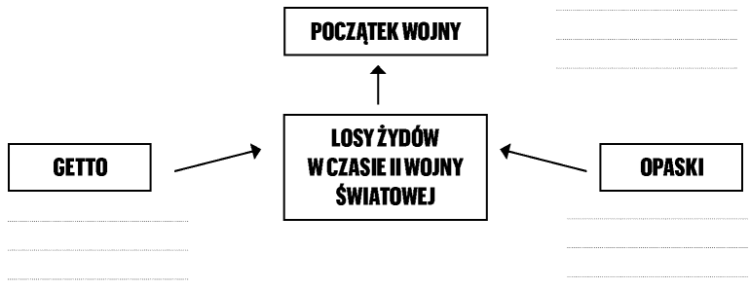
POLISH | ENGLISH
POCZĄTEK WOJNY | THE BEGINNING OF WAR
GETTO | GHETTO
LOSY ŻYDÓW W CZASIE II WOJNY ŚWIATOWEJ | FATES OF JEWS IN THE TIME OF WORLD WAR II
OPASKI | ARMBANDS

MATERIAL FOR ACTIVITIES NO. 1
WORK CARD
Read the excerpt from the book “All my Mums” and look at the photo. Answer the questions:
1. Who wore the armband, where and why?
2. How were people wearing armbands treated?
3. What emotions were experienced by the protagonist when he found out about the order to wear armbands?
“My whole family wore such armbands with a star,” he resumed the story. “At first I was glad, because I liked this star, but I did not say it out loud.
- Remember, when getting out, you must always put it on - my mom warned us.
I quickly found out that these armbands were not worn for decorations.
- They are so the Germans at first glance know who among the people on the street is a Jew - Chana told me – they can hit a Jew, topple and even shoot him without any reason.
- Well, so it's best not to wear these stars – I got scared.
- Are you crazy?! They announced that they would immediately kill any Jew who would show up in the city without an armband - Chana shrugged helplessly.”
Wszystkie moje mamy (All My Mums), R. Piątkowska, M. Szymanowicz, Łódź 2013, p. 12.
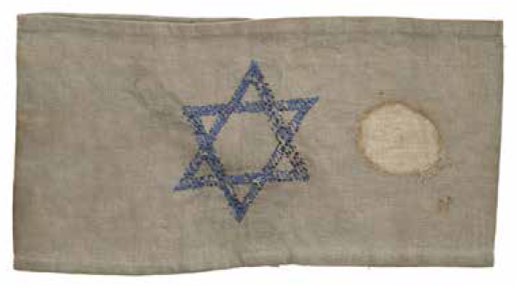
Source: Collections of the POLIN Museum of the History of Polish Jews
MATERIAL FOR ACTIVITIES NO. 2
WORK CARD
Read excerpts from the book “Time Ark” and “The Island on Bird Street’”
Answer the questions:
1. Why were the closed districts in the city established?
2. What conditions prevailed in the closed district, and how was it outside? Complete the table.
The closed district | The world outside the wall
1.  2.  3.  4. | 1.  2.  3.  4.
3. What feelings and emotions were experienced by those in the closed district?
“I have the impression that I have always lived here. That there has always been the District, and always too little food and too many people. That there has always been a war and that you must constantly remember to be afraid - even when you are not afraid. This tires me sometimes very much. I think that if I remembered my parents, the river, the forest and our Saska Kępa, it would make it so much easier for me.”
Arka czasu (Time Ark), M. Szczygielski, Warsaw 2015, page 26.
“Imagine the city, the one where you live, or the one that is closest to your place. Imagine that your city has been occupied by a foreign army and that, in addition, some of the inhabitants have been separated from the majority; let us say: all those with black or yellow skin or all those with green eyes. Imagine also that they have not only been separated from the rest, but imprisoned in one of the districts of the city, and a high wall was built around it. This wall obviously goes along or across certain streets, and even divides individual homes and their backyards into two parts. In this walled district, everything remained as before: cinemas, schools, nightclubs, hospitals and various shops. But because of the wall and a few guarded entries, which can be crossed only with a special pass, the stores are supplied with only a small fraction of goods they were selling (...). Public transport also does not work. Buses, trams and cars have disappeared, and the streets are full of rickshaws [a bicycle with a cart to carry passengers].
If you are brave or in a desperate situation, you can try to smuggle food from other parts of the city to your walled district. If they catch you, they'll shoot you, even if you're a little boy or a little girl.
From this it clearly transpires that the difference between the rich and the poor is not only about how one lives, dresses and eats. This is a matter of life and death. The rich have food, and the poor are dying of hunger, and no one is able to help them.”
Wyspa przy ulicy Ptasiej (The Island on Bird Street), Uri Orvel, Poznań 2011, pages 4-5.
AUTHOR: MARIA PAWLAK
THE EDUCATIONAL STAGE: GRADES 4-6 OF PRIMARY SCHOOL
TITLE: MEMORY AND COMMEMORATION
DURATION: 45 MINUTES

OBJECTIVES IN THE PUPIL'S LANGUAGE:
1. YOU WILL LEARN ABOUT DIFFERENT WAYS OF COMMEMORATING HISTORICAL EVENTS AND THEIR HEROES.
2. YOU WILL IMPROVE YOUR SKILLS OF WORKING IN A GROUP.
3. YOU WILL LEARN ABOUT PLACES AND PEOPLE RELATED TO THE WARSAW GHETTO UPRISING.
THE COURSE OF THE EXERCISE AND TIPS FOR THE TEACHER:
1. Divide the class into groups, distribute work cards (material for activities no. 1). You can also conduct the exercise together with the whole class - you can write on the board the answers to the question: what can be commemorated and how can it be done?
2. Together with the class summarize the task from the work card. Write the reoccurring ideas on the board.
3. Display to the class photos of various types of commemorations (teacher’s material no. 1), name them together: 1. Ceremony / solemn celebration, 2. Street name, 3. Mural, 4. Monument, 5. Animated film. Ask the pupils whether they could do/make any of the presented commemorative forms themselves? Refer to the work card being completed by the groups; are the examples of commemorations given by pupils similar to those shown in the photos?
4. Pupils will again work in groups. Their task will be to create a sculpture that will reflect the word ‘memory’ (material for activities no. 2).
5. The groups will present the effects of their work. They start with presenting on the forum sculptures depicting the word “memory.” In the next round, they add sound and movement to the static sculpture. In the last round, each group presents the title of the created installation. Summarize the task with pupils. Ask if the task was easy? Is it possible to commemorate events and people in this way? At the end ask how they understand the difference between the words: memory and commemoration.
6. Show to students the film: https://www.youtube.com/watch?v=uCMrT39CrL4 Ask what they saw in the film? What event and how was it commemorated? Explain that the Daffodils action presented in the film is a way of commemorating the anniversary of the Warsaw ghetto uprising, which began on April 19, 1943. One of the ghetto survivors was Marek Edelman, the last leader of the uprising. On April 19, on the anniversary of the uprising, he laid a bouquet of yellow flowers at the Monument to the Ghetto Heroes in Muranów. The POLIN Museum continues this tradition, handing out thousands of paper daffodils on the streets of Warsaw.
7. At the end, give to each pupil a template of a daffodil to be made. Everyone by themselves will make a paper flower and will attach it to the dress as a sign of memory.
TEACHER’S MATERIAL NO. 1
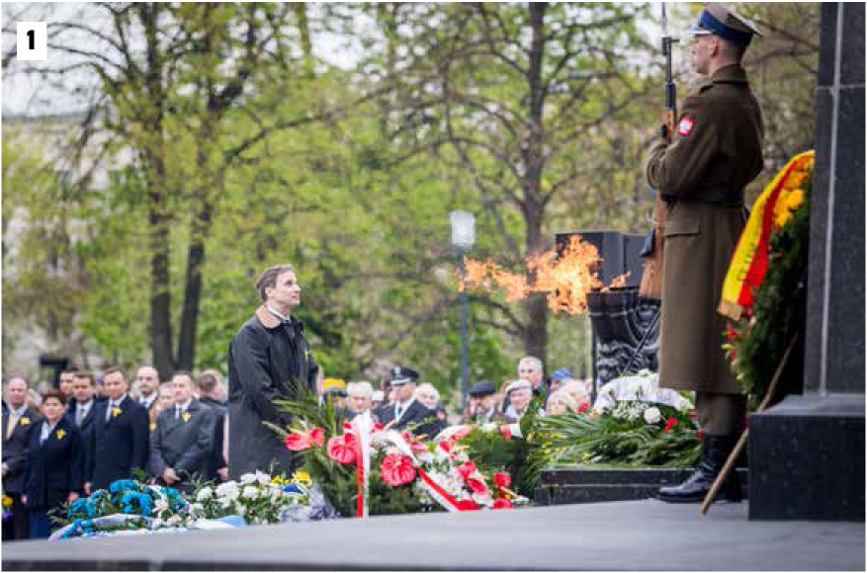
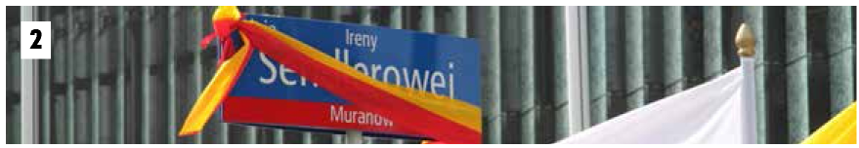
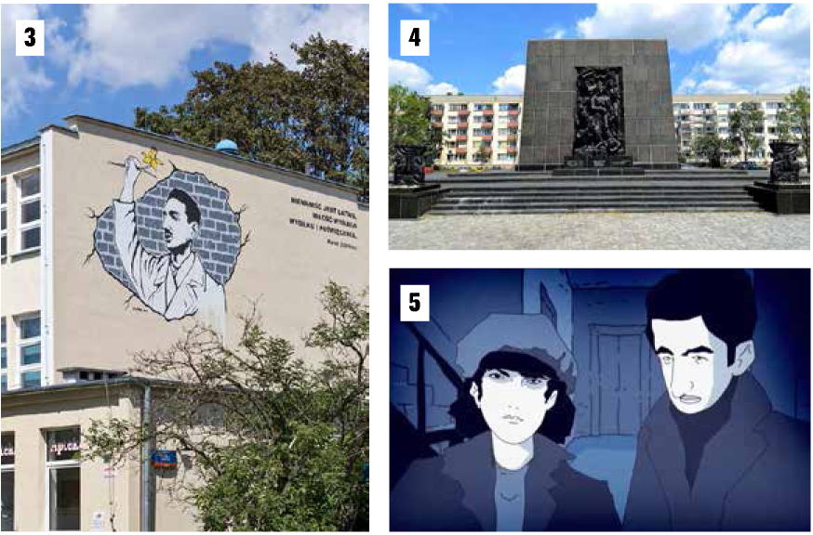
MATERIAL FOR ACTIVITIES NO. 1
WORK CARD
Think about what it means to “commemorate” and how it can be done. Thought related to it or examples should be written in the appropriate fields of the table:

COMMEMORATING
WHAT? | HOW?
MATERIAL FOR ACTIVITIES NO. 2
INSTRUCTION FOR THE GROUP
In your groups you will be tasked to use your bodies - hands, legs, heads - to create a sculpture that in your opinion reflects the word “memory.” You have 5 minutes to design the sculpture. After showing the sculpture on the forum, you will have to add movement and voice to it. At the end, give the name to the created installation.

AUTHORS: KATARZYNA KULIŃSKA, JOANNA OLENDER
THE EDUCATIONAL STAGE: GRADES 4-6 OF PRIMARY SCHOOL
TITLE: RESCUING HANNAH
DURATION: 20 MINUTES

OBJECTIVES IN THE PUPIL'S LANGUAGE:
1. YOU WILL GET TO KNOW THE STORY ABOUT HANNAH GOFRIT.
2. YOU WILL IMPROVE YOUR SKILLS RELATED TO UNDERSTANDING TEXT.
THE COURSE OF THE EXERCISE AND TIPS FOR THE TEACHER:
The exercise is based on excerpts from the story about Hana Gofrit written by Nami Morgensztern and published under the title “Chciałam wzlecieć jak motyl” (I Wanted to Fly Up Like a Butterfly). The entire book, along with didactic guidelines for teachers to work on the full story of Hannah Gofrit, is available on the Yad Vashem website.
1. Ask pupils what associations the word ‘hiding’ brings to their minds. Write them on the board.
2. Introduce to the pupils the story about Hana Gofrit (teacher’s material no. 1).
3. Hand out to pupils excerpts 24, 25 and 28 of the book “I Wanted to Fly Up Like a Butterfly” (material for activities no. 1). Read them aloud and then discuss them with the pupils. Ask them:
a) Why was Hana hiding in the house of Skowronek family? // Explain that during World War II Jews were not allowed to live outside ghettos. That is why Hana and her mother could not go out of their hiding place for two years - they were afraid that someone would recognize and denounce them. It was a threat to both Hana and the Skowronek family. Hiding Jews in occupied Poland was punishable by death.
b) What Hana's daily life looked like?
c) What the daily life of Skowronek family looked like?
4. Summarize the exercise - return to the associations written at the beginning of the lesson. Ask pupils whether their associations relate to Hana’s emotions described in the text.
5. Hand out to pupils excerpts 26 and 27 from the book “I Want to Fly Up Like a Butterfly” (material for activities no. 2). Read them aloud and then discuss them with the pupils. Ask them:
a) What was the ghetto?
b) What happened in the ghetto?
c) Why did Mrs Skowronek “praise” Jews?
Ask pupils if they know of any other uprisings that took place during World War II. Point out that two uprisings took place in Warsaw: the first - the Warsaw Ghetto Uprising in 1943, and the second - the Warsaw Uprising in 1944. You can tell students about ghetto insurgents who also fought in the Warsaw Uprising in 1944 (among them were Marek Edelman, Cywia Lubetkin, Symcha Ratajzer).
7. Summarize the lesson, tell how the story of Hana ended, that she and her mother survived the war. Later they departed for Israel. Hana became a nurse. Mr and Mrs Skowronek were awarded the title of Righteous Among the Nations.
TEACHER’S MATERIAL NO. 1
Hana was the daughter of Herszel and Zisia Herszkowicz. They came from the town of Biała Rawska, where before the war many Jewish and Polish families lived side by side. When Hana was 4 years old, war broke out. Hana did not understand what was going on around her, why Jews had to live in the ghetto and wear markings on their clothes, or why, at the beginning of the school year, she could not go to school with other children. Hana’s mum was a dressmaker. During the occupation she sewed clothes for Poles and Germans, so she did not have to move to the ghetto. Thanks to her occupation, the family situation was relatively good - they could afford food for themselves and to help other Jews.
Most of the Jews from Biała Rawska were deported from the ghetto by Germans and perished. Hana and her parents managed to escape and find shelter in a nearby farm. For some time they hid in the pigsty, and the hosts brought them food. Unfortunately, anxious of being detected by Germans, Hana's family had to separate and seek another refuge. Hana's dad decided to hide in a forest, where he wanted to join the partisans. Hana and her mother received documents - Polish ID cards - so they could go to Warsaw, to the Skowronek family, who agreed to help them.
MATERIAL FOR ACTIVITIES NO. 1
Excerpts 24, 25 and 28 from the book I Want to Fly Up Like a Butterfly by Nami Morgensztern and published by Yad Vashem.
24.
“I came to Warsaw with my mum. No one recognized that we were Jewish. We went to the house number 64 at Żelazna street. There, on the sixth floor was the flat of Skowronek family. Mrs Skowronek was the sister of Mrs Moszałkowa, our neighbour in the town. The Skowronek family agreed to accommodate us. We lived with Skowronek dad, who was an electrician, Skowronek mum, who sold soap at the market and with girls Hanka and Basia, who went to school. We lived with them for two years.
For two years we did not leave the flat because we were scared.
For two years we did not approach the window. I always walked on all fours under it.
For two years, Hanka and Basia did not bring their friends home. It was not allowed to tell anyone that we were in the apartment. It was a life-saving secret. Mum was responsible for keeping the house in order. She also cooked the soap that Mrs Skowronek sold at the market. She sewed and mended the clothes of household members. In the evening she helped girls with their homework. I was able to answer their school assignments, but I refrained from saying anything so as not to disturb or irritate. In the morning, when the family went out, I felt like a queen. I watered flowers that I received from Mrs Skowronek. I read girls’ books, walked on all fours under the window, listened to the sounds of children playing in the yard. I talked to mum. In a whisper. So that no one would hear us.”
25.
“I sat at the door and listened to the sounds of people coming up and down the stairs. I recognized all the steps of the household members. I knew when they would come and waited for the clang of the door handle, it was a cue to open the door. None of the household members rung the bell or knocked. When someone knocked or rang, I felt that I failed because I didn’t hear the upcoming steps. So I waited tensely until the steps move away.”
28.
“When we were hiding in the Skowronek family’s apartment, no one was allowed to find out that we lived there. Therefore, when guests came, my mother and I had to hide in the wardrobe. Once a guest came without notice and we did not manage to hide in the wardrobe. We jumped into the coal box. Mrs Skowronek sat on this box during the whole visit, until the guest went away. Sometimes we had to sit in the wardrobe for hours, motionless and soundless.
In the wardrobe, I imagined that I was a little dwarf in a forest, wearing blue clothes and a red cap with a pompom. I imagined that I was walking among flowers, drinking dew and recognizing each flower by its smell.”
MATERIAL FOR ACTIVITIES NO. 2
Excerpts 26 and 27 from the book I Want to Fly Up Like a Butterfly by Nami Morgensztern and published by Yad Vashem.
26.
“The apartment of Skowronek family was very close to the Warsaw ghetto. Germans ordered all Jews from the city to live in the ghetto. It was a huge ghetto. Mrs Skowronek said that several Jews from the ghetto came to the market and talked about congestion, hunger and diseases. They also said that the Jews were deported from the ghetto by trains. Mrs Skowronek said that people talk about something being prepared in the ghetto...
One night, when everyone was asleep, we heard the sounds of explosions from the ghetto and the sky turned red. I could not stand it, I sneaked to the window. I met my mum near the window. We didn’t say anything, we just cried. We knew that the Jews who remained in the ghetto, with their last ounce of strength were fighting against German soldiers and that a handful of Jews with rifles were confronting German soldiers with machine guns and tanks. The Jews didn’t stand a chance. One night there was an alarm. Germans bombed the ghetto. All the residents of the house went to the shelter. I stayed with my mum in the apartment. Mum laid on top of me and told me not to look. But I was peaking. Through the window I saw a falling bomb - and I was shocked”.
27.
“The bomb was not round, as I imagined. It had the shape of a bottle. We were laying there until the bombing ended. A few days later, Mrs Skowronek said that there was not a single Jew left in the ghetto and that the entire ghetto had been burnt. She praised the Jews and said that the people at the market say that the Jews dared to mount what Poles have not yet dared - the rebellion.”

